**Gold Standard for the Global Goals**

**Key Project Information & Project Design Document (PDD)**



**Version 1.1 – August 2017**

**KEY PROJECT INFORMATION**

|  |  |
| --- | --- |
| Title of Project: | Efficient Cookstoves in Bahia III |
| Brief description of Project: | Efficient Cookstoves in Bahia III reduces greenhouse gas emissions by substituting rudimentary stoves with efficient cookstoves for domestic use. Three thousand stoves will be installed, directly benefitting three thousand low-income rural families in Bahia state in northeastern Brazil, with especially positive impacts for women and children. |
| Expected Implementation Date:  Expected duration of Project: | April 1, 2018  10 years |
| Project Developer: | Instituto Perene |
| Project Representative: | Guilherme Prado Valladares |
| Project Participants and any communities involved: | 3,000 families from the municipalities of Cruz das Almas and Nazaré, Recôncavo region, Brazil |
| Version of PDD:  Date of Version: | 4  19 March 2018 |
| Host Country / Location: | Brazil |
| Certification Pathway (Project Certification/Impact Statements & Products | Impact Statements & Products |
| Activity Requirements applied:  (mark GS4GG if none relevant) | GS4GG |
| Methodologies applied: | Microscale Methodology for Improved Cookstoves Version: 1.0 |
| Product Requirements applied: |  |
| Regular/Retroactive: | Regular |
| SDG Impacts: | 1 – SDG 13 Climate Action  2 – SDG 7 Affordable and Clean Energy  3 – SDG 1 No Poverty |
| Estimated amount of SDG Impact Certified | 76,425 tons CO2e |
|  |  |

* 1. Description of project
     1. Purpose and general description of project

>> *(Provide a brief description of the project including the description of scenario existing prior to the implementation of the project.)*

The Efficient Cookstoves Project is an initiative developed and executed by the Brazilian NGO Instituto Perene that reduces greenhouse gas emissions by substituting 3,000 rudimentary stoves with efficient cookstoves for domestic use. Three thousand low-income rural families in Bahia state in northeastern Brazil will directly benefit from this project, with especially positive impacts for women and children. Instituto Perene has two other cookstove projects, GS832 and GS1028, underway in the region. Instituto Perene is now expanding this successful cookstove initiative to additional municipalities in Bahia through this project, Efficient Cookstoves in Bahia III.

The type of project activity proposed is an End-use Energy Efficiency Improvement, reducing the amount of energy required for domestic cooking in rural households, by substituting inefficient, rudimentary cookstoves with improved, efficient cookstoves.

Approximately 3o million people in Brazil still depend on firewood for domestic cooking, with the highest concentration in the country´s Northeast (Gioda, 2017).

The characteristics of the households involved in the project are:

* rural
* low-income
* population of African descent
* gather firewood from local forest fragments
* cook primarily with wood
* cook on open-air fires.

Northeast Region has Highest Illiteracy Rate of Brazil



The Northeastern region of Brazil has the highest concentration of poor people in all of South and Central America. Within the country, the project focus state of Bahia is home to the largest population considered extremely poor (income under US$35/month) and poor (income between US$35 and 65/month) (de Castro, 2011). Although significant socio-economic progress has been made in rural Bahia in the past decades, indicators such as illiteracy rate (table at left), demonstrate there is still much to be done. Brazil´s northeast, circled in red, has the highest illiteracy rate in the country (IBGE, 2011)

Traditional stoves are composed of a few stones or loose bricks, cobbled together to support a pot over an open fire. These rudimentary devices do not have a chimney and have extremely low thermal efficiency, below 10%, with high emission of pollutants, especially particulate matter (Gioda, 2017).

The use of these baseline stoves cause several problems:

* Household air pollution, which is especially damaging to the health of women and children who suffer from daily exposure to smoke and particulates
* Deforestation, resulting from the high consumption of wood
* Global warming, due to the emission of unnecessary amounts of greenhouse gases
  + 1. Eligibility of the project under Gold Standard

>> *(Describe how the project meets the eligibility criteria as per section 3.1.1 of GS4GG Principles & Requirements document and the relevant activity requirements document)*

This project is eligible under the Gold Standard classification of “Improved distributed heating and cooking devices (e.g. cookstoves), and distributed micro-scale electricity generation units.” The project is expected to reduce 76,425 tons of CO2-eq over one crediting period of 10 years, with an average reduction of 7,600 tons CO2-eq per year. As this is within the limit of 10,000 t CO2-eq, this project is classified as micro-scale. Should ER in any given year surpass 10,000 t CO2-eq, the surplus ERs will be disconsidered.

The project follows Pathway 1 of the Gold Standard Gender Equality Guidelines & Requirements.

* 1. Foundation gender-sensitive requirements: These requirements are mandatory for all projects and include compliance with the Gender Safeguarding Principles and Requirements and gender sensitive stakeholder consultations.

The 3 steps of Pathway 1 are:

1. Basic context : From the initial concept, women have been the driving force of this project. The problems of rudimentary stoves affect women disproportionately as they carry out the greater part of cooking and child-rearing activities, which center around the kitchen and the hearth. It was through the vocal participation of women that the Perene stove model was designed, and it is to the credit of the local cooks and masons that the model has met with widespread acceptance and enthusiasm. By enlisting the help of female Community Agents, women have been empowered with new information, new skills and ownership of a new asset. The stove is made available to both men and women equally. In Perene two current GS projects, GS832 and GS1028, over 80% of owners of new stoves are women.
2. Safeguards assessment : The project contributes to gender equality and empowerment of women. Not only does the project NOT put at risk women´s access and control of resources, it in fact INCREASES the resources available to women, these being - a new asset, the stove, new authority, as the signatory of the Terms of Authorization, new mechanisms for voicing their feedback, through monitoring interviews and grievance mechanisms, and new status in their community as participants of a progressive program bringing new information and resources to the region. Furthermore, not only does the project NOT increase women´s workload, it in fact DECREASES the workload in a significant way by decreasing the time and energy necessary to collect fuelwood and the drudgery of cleaning kitchenware.
3. Stakeholder consultations: women are always the majority in Perene´s stakeholder consultation meetings and the same is true of the Local Stakeholder Consultation meeting held for GS6050. By having female Community Agents invite participants to the meetings by word of mouth and through door-to-door visits, the project ensures that it is actively engaging women to participate in the project.

After completing the three steps of analysis, which are further detailed below in Section A.8. Assessment that project complies with ‘gender sensitive’ requirements, the project developer finds the proect is in full compliance with the GS Gender-Sensitive guidelines and requirements.

* + 1. Legal ownership of products generated by the project and legal rights to alter use of resources required to service the project

>> *(Justify that project owner has full and uncontested legal ownership of the products that are generated under Gold Standard Certification and has legal rights concerning changes in use of resources required to service the Project for e.g. water rights, where applicable.*)

The transfer of credit ownership throughout the investment chain is made transparent through written contracts. Each project beneficiary signs a contract, the Authorization and Transfer of Carbon Credit Rights, transferring the ownership rights to the carbon credits to Instituto Perene. The cookstove end-users are fully aware of and willing to cede rights to carbon credits generated by emission reductions in exchange for obtaining an efficient stove and participating in the program, and this has been documented through video footage of the stakeholder meetings and interviews.

The terms of the contract with each stove-owner are as follows (translated from the Portuguese):

*I, (name), carrier of national identification document no. (number), resident of (community), agree to participate in the Efficient Cookstoves III Project. I authorize the technicians from Instituto Perene to install one efficient wood-burning cookstove in my home. In return for this installation, I transfer all rights to the carbon credits resulting from the reduction of greenhouse gases generated by using this stove during 10 years to Instituto Perene.*

*I declare that firewood is the main fuel used for cooking in my home.*

*I declare that I have never participated in an improved cookstove project before, nor received an improved cookstove through any other initiative.*

*Upon prior request, I agree to allow access to the stove installed in my home by Instituto Perene´s technicians so that they may assess the stove conditions and collect data about the generation of carbon credits, including taking photos. I authorize the use of images of the stove and members of this household for monitoring and dissemination purposes. I agree to follow the instructions received for correct use of the stove and to communicate any problems with the stove to Instituto Perene.*

Individual contracts signed by each of the 3,000 stove-users transfer the carbon credit rights to Instituto Perene. A separate contract transfers the carbon credit rights from Instituto Perene to the buyer of the Verified Emissions Reductions (VERs).

* + 1. Location of project
       1. Host Country

Brazil

* + - 1. Region/State/Province etc.

Recôncavo Region, Bahia state, Northeast Brazil

* + - 1. City/Town/Community etc.

Cruz das Almas and Nazaré

* + - 1. Physical/Geographical location

Municipalities of Cruz das Almas and Nazaré in the Recôncavo region of Bahia state, Brazil.

|  |  |
| --- | --- |
|  | **Coordinates** |
| **Latitude** | 12.6736° S |
| **Longitude** | 39.1017° W |

Instituto Perene is the implementing organization and will conduct the project onsite and from its office in Salvador, Bahia:

Contact person: Guilherme Monteiro do Prado Valladares

Address: R. Belo Horizonte, 64, sala 310

Salvador, Bahia 40140-380

Phone: +55 (71) 3264-3199

* + 1. Technologies and/or measures

The efficient stove design is based on principles originally laid out by Dr. Larry Winiarski and Aprovecho Research Center (Bryden, Still, Scott, & Hoffa, 2002). The cookstove model used in this project was further developed with the participation of local masons, cooks and community leaders. The technology to be employed uses locally available materials and labor. It is constructed using regular and refractory bricks, regular and refractory mortar, a metal plate with 2 openings, a rocket-elbow combustion chamber, autoclaved aerated concrete for insulation, and a ceramic chimney.

Efficient and Durable Cookstove model

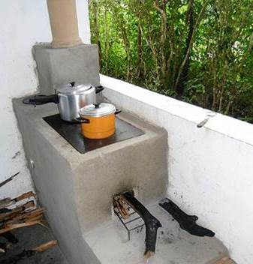

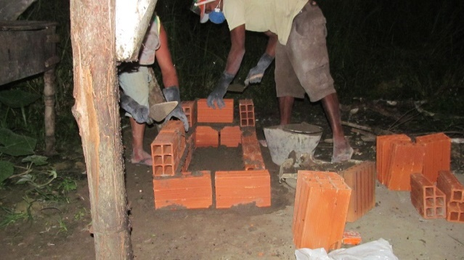 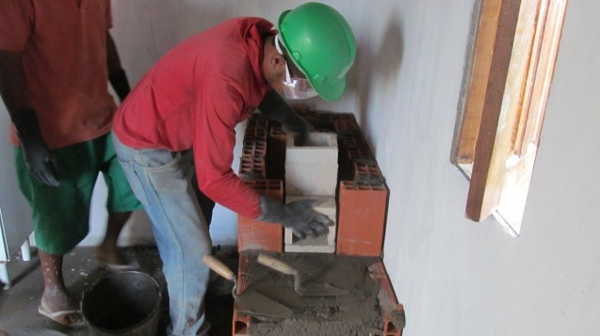

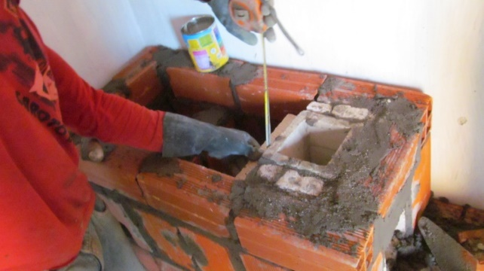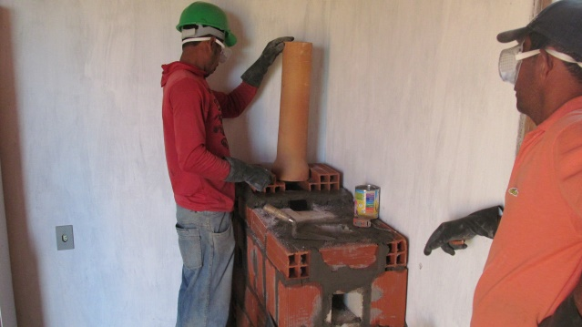

Stages of construction of the efficient cookstove: clockwise from top left: stove base, placement of combustion chamber, insulation surrounding combustion chamber, chimney installation.

The result is an efficient, durable stove that is well-suited to the needs and customs of its users. The improved cookstove developed for this project is the product of a participative process that included Instituto Perene, Aprovecho Research Center, local masons and stove-users in the project region. Mike Hatfield, a consultant from Aprovecho Research Center with over 10 years of experience in stove design and construction brought his international expertise in stove-building to the project.

The operating life of the stove has been defined by Instituto Perene to be 10 years. Instituto Perene´s stove model, developed together with Aprovecho Research Center, is similar to the Justa stove, with the same robustness that comes from being a fixed model with a brick and mortar stove housing. The Justa stoves have proven in the field to have a useful life near 10 years (Peter Scott, p. 11) . The earliest of Perene´s own stoves (under project GS832) have now been operating over 8 years, having been installed in 2009. The durability of the stove model is due to the selection of extremely robust materials used in the stove:

* Combustion chamber made of refractory brick of 2.5 cm thickness, and refractory mortar. The thickness was chosen to avoid the fracture that sometimes occurs when firewood is pushed too far in the stove, hitting the back of the chamber. Refractory brick is made to withstand high temperatures while having low thermal conductivity. According to the manufacturer´s specifications, the bricks are 38% Al2O3, resistant to 1280º C and can withstand compression of 250 KgF/cm2. (Gabriella Refratarios)
* AAC used as isolative material. Autoclaved Aerated Concrete is widely used for its characteristics of thermal isolation, lightweight and long durability, this material is described as follows: “A cement-based material, AAC resists water, rot, mold, mildew, and insects.” (Portland Cement Association)
* Brick and mortar housing. Differently from metal structures or other portable models, the fixed model has the proven durability of masonry.
* Ceramic chimney. When the first Perene stoves were built in 2009, chimneys were made of galvanized steel. However, these showed signs of corrosion after a few years and were replaced with ceramic. As of 2011, all Perene stoves are equipped with ceramic chimneys. According to Aprovecho Research Center, chimneys of this material have a durability of 10+ years (Peter Scott, p. 12)

Wood-burning stoves release CO2, CO, CH4 and other greenhouse gases and products of incomplete combustion into people’s homes and into the atmosphere (Smith, 2006). The improved cookstoves designed for this project have double the efficiency of the baseline stove, therefore delivering the same amount of cooking energy to the pot with a lower amount of fuel. The reduction in fuelwood burned in turn reduces the amount of anthropogenic GHG emissions generated. In the absence of this project, the baseline scenario would be the continued use of larger quantities of wood for cooking. Therefore, the emission reductions are calculated based on the annual savings of non-renewable biomass multiplied by an emission factor for wood-based cookstoves.

* + 1. Scale of the project

>> *(Define whether project is micro scale, small scale or others. Justify the scale referring to relevant activity requirement.)*

Micro-scale. This project activity will install 3,000 efficient stove units and is expected to reduce 76,425 tons of CO2-eq over 10 years, averaging 7,642 tons of CO2-eq per year. Since the annual emissions reduction is less than 10,000 tons of CO2-eq per year, this project is classified as a “micro” scale Voluntary Emissions Reduction (VER) project. In any given year, should the emissions reductions surpass the limit of small-scale project ER of 10,000 tons, the tons in excess of 10,000/year will not be credited.

|  |  |
| --- | --- |
| Year | Net Emission reduction |
| tCO2/year |
| 2018 | 5,396 |
| 2019 | 10,000 |
| 2020 | 9,705 |
| 2021 | 9,170 |
| 2022 | 8,538 |
| 2023 | 7,918 |
| 2024 | 7,309 |
| 2025 | 6,711 |
| 2026 | 6,126 |
| 2027 | 5,552 |
| Total | 76,425 |
| Annual emission reduction | 7,642 |

* + 1. Funding sources of project

>> *(Provide the public and private funding sources for the project. Confidential information need not be provided.)*

Instituto Perene is currently seeking funding for this carbon project. The Brazilian company Natura, through its voluntary corporate offset program “Natura Carbono Neutro” launches requests for proposals to offset its emissions through the purchase of carbon credits from projects located in Brazil. Instituto Perene has three carbon-credit purchase contracts with Natura from previously selected projects, and is seeking a fourth contract. The current call for proposals closes October 13, 2017. Information can be found at:

<https://www.ekos.social/pages/natura-itau>

As of February 2018, Instituto Perene has made the short-list of selected projects. Legal documents are being reviewed by Natura and price and other contractual conditions are under negotiation. Final approval of this carbon project by Natura and disbursement of funds is expected by Apri 2018.

* + 1. Assessment that project complies with ‘gender sensitive’ requirements

>> *(Answer the four mandatory questions included under Step 1 to 3 in “Gold Standard Gender Equality Guidelines and Requirements” available* [*here*](https://globalgoals.goldstandard.org/100_g/101-1-g-gold-standard-gender-guidelines)*.)*

**1M. Does the project reflect the key issues and requirements of gender-sensitive**

**design and implementation as outlined in the gender policy?** Explain how.

From Gold Standard Gender Policy, p. 10:

*Foundational gender-sensitive requirement - This strengthens Gold Standard’s*

*‘do no harm’ approach and addresses safeguards to prevent or mitigate adverse*

*impacts on women or men and girls and boys. Such action is mandatory for all*

*projects seeking Gold Standard certification and includes compliance with the*

*gender ‘do no harm’ safeguards, gender gap analysis and gender sensitive*

*stakeholder consultations.*

This project is gender-sensitive in design as women have been involved from the very beginning, in the design of the efficient cookstove model, as Community Agents, in leadership and in monitoring activities. In addition, data on stakeholder participation and beneficiaries is segregated by gender. The project is gender-sensitive in implementation, since at least 80% of stove owners are female. These women take on an important role as they are responsible for signing the Terms of Agreement, determining, with the construction team, where they want their new stove built, giving feedback during HH visits and surveys and sharing information with other community members about the project. Not only does the project “do no harm”, in fact it strongly empowers women through information, technology, decision making and increased status in their community.

**2M. Does the project align with existing country policies, strategies and best**

**practices?** Explain how

Yes, this project is fully aligned with Brazilian policies for gender equality. Brazil´s national gender policies are spearheaded by the Ministry of Justice and Citizenship, under the Special Secretariat for Women´s Policies. The overarching mission of the Secretariat is:

*Promoting the capacity and participation of women in the roles of power and decision-making, based on the understanding that the under-representation of women has diverse causes. Therefore, changes must be promoted in various social spheres including: cultural, educational, legislative and institutional* (Ministerio da Justiça e da Cidadania, 2017).

Main actions outlined by the Secretariat and how the Project contributes:

1. *Support the capacity-building of women leaders*

This project will engage approximately 2,500 women who will become owners of a modern wood-burning stove and receive information and training on environmental and safety issues directly from other rural women. Female voices will be valued with feedback solicited and recorded from hundreds of women through house-hold monitoring visits and community meetings. By having women sign the Terms of Agreement, this project formalizes the role of a woman as a leader of the household in the position to sign documents and consider conditions, and recognizes the woman stove participant as the original owner of the carbon credits. In addition, the project will have at least two women directly involved in implementation and monitoring and receiving fair monetary compensation for activities.

1. *Make available data, information and studies on the subject of gender.*

This project will generate annual monitoring reports that will be publicly-available, containing data on number and percentage of women vs men involved in domestic cooking. In addition, participation lists of meetings and workshops have data segregated by gender, as does the Project installation database.

**3M. Does the project address the questions raised in the Gold Standard**

**Safeguarding Principles & Requirements document?** Explain how.

*The Project shall complete the following gender assessment questions in order to inform Requirements 2-4, below:*

1. *Is there a possibility that the Project might reduce or put at risk women’s access to or control of resources, entitlements and benefits?* No, on the contrary, the Project increases women´s access to technology and benefits with the construction, in their home, of an efficient cookstove. Women can choose if they want to participate, their feedback is requested and recorded, and they become active participants in their process.
2. *Is there a possibility that the Project can adversely affect men and women in marginalised or vulnerable communities (e.g., potential increased burden on women or social isolation of men)?* No, the Project beneficiaries are in fact these vulnerable communities, home to a low-income rural population, mainly of African and indigenous descent, who have limited access to education and improved technology.
3. *Is there a possibility that the Project might not take into account gender roles and the abilities of women or men to participate in the decisions/designs of the project’s activities (such as lack of time, child care duties, low literacy or educational levels, or societal discrimination)?* No, since the cookstove is built in the person´s home, there is no need to travel or be absent from their daily routine. The Terms of Agreement use simple language and Community Agents and the building team are all from the region and it communication with Project participants is very effective.
4. *Does the Project take into account gender roles and the abilities of women or men to benefit from the Project’s activities (e.g., Does the project criteria ensure that it includes minority groups or landless peoples)?* Yes, the Project benefits exclusively low-income, rural families. Firewood use is characteristic of poor families, and it is the main criteria for participating in the Project.
5. *Does the Project design contribute to an increase in women’s workload that adds to their care responsibilities or that prevents them from engaging in other activities?* No, on the contrary. Women report less time spent collecting fuel and cleaner kitchens and cooking utensils, reducing the time and drudgery of housework.
6. *Would the Project potentially reproduce or further deepen discrimination against women based on gender, for instance, regarding their full participation in design and implementation or access to opportunities and benefits?* No, as shown by the LSCM and in the Project databases of Perene´s two other cookstove projects, GS832 and GS1028, women fully participate in the design and implementation, opportunities and benefits of the Project. The majority of the Project beneficiaries are women.
7. 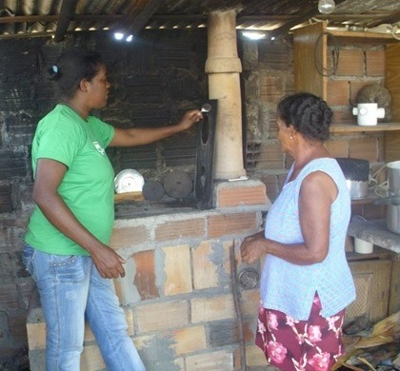*Would the Project potentially limit women’s ability to use, develop and protect natural resources, taking into account different roles and priorities of women and men in accessing and managing environmental goods and services?* No, in fact, by adopting the efficient cookstove, women will be using less wood from the Atlantic Rainforest and thereby increasing protection for natural resources.
8. Is there a likelihood that the proposed Project would expose women and girls to further risks or hazards? *No, in fact, the closed combustion chamber and raised stove is far safer and protects family members from burns and accidents common to open-air fires. Reduced time and trips collecting wood also increases safety overall.*

Community Agent teaching stove owner

**4M. Does the project apply the Gold Standard Stakeholder Consultation &**

**Engagement Procedure Requirements?** Explain how.

Yes, the project applies the stakeholder-related procedures. From the GS Stakeholder guidelines, section 1.4:

*In developing a Project, “taking gender issues into account would require that local stakeholder consultation processes reach a wide range of community representatives in ways that ensure equal and effective participation of women and men in consultation, and that gender issues are fully factored into comprehensive social and environmental impact assessments."*

**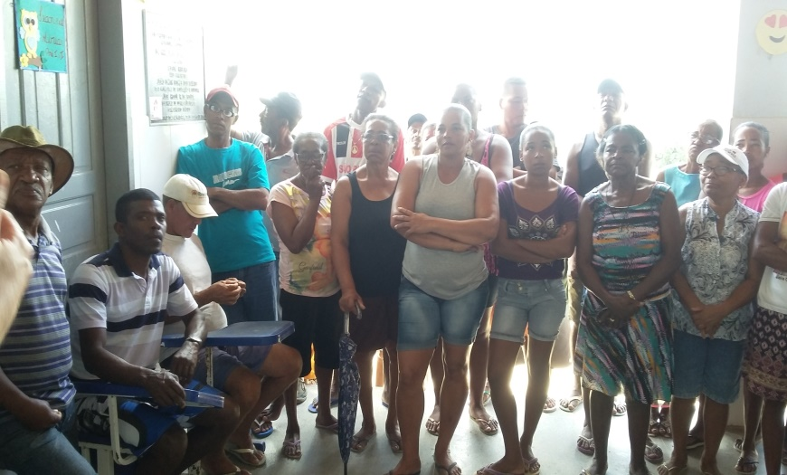**

The Local Stakeholder Consultation Meeting effectively engaged both men and women. Of a total of 77 local participants, 47 were women and 30 were men. The meeting was held on a Sunday so as not to interfere with the regular schedule of the week. It was held during the day, as women tend to circulate more freely and safely then than after sunset. Word of mouth was used as the means of invitation, with Perene´s female Community Agent visiting door-to-door to invite local villagers. Women were vocal at the meeting, speaking at length about the hardship of cooking over open fires and the effect that the smoke had on their eyes and lungs, and asking about the timeline and requiprements of participating in the Project.

Women were the majority at the Project LSC meeting

* 1. Application of selected approved Gold Standard methodology
     1. Reference of approved methodology

This project applies the [401.13 ER MS CS] MICROSCALE METHODOLOGY FOR IMPROVED COOKSTOVES, also known as Gold Standard Simplified Methodology for Efficient Cookstoves, effective February 2013, which includes both the baseline and monitoring methodologies.

* + 1. Applicability of methodology

>> *(Justify the choice of the selected methodology(ies) by demonstrating that the project meets each applicability condition of the applied methodology(ies))*

This methodology is applicable because the proposed project is a micro-scale activity that introduces new wood burning cookstoves to reduce the use of non-renewable firewood to meet thermal energy requirements for household cooking.

The project proponent, Instituto Perene, is implementing the activity; the individual households do not act as project proponents.

The conditions are stated and met as follows:

1. If:
2. the baseline fuel is only firewood.

All of the project households use firewood as their main cooking fuel. This is a requirement for households to be eligible to receive the stove, and it is included in the individual agreements signed by each stove user. At the time of installation of each project cookstove, a photo is captured of the old stove used in the household before it is destroyed. Generally, the new cookstove is constructed in the place of the old stove, eliminating the baseline stove completely.

In addition to firewood, it is the wide-spread cultural practice to have a gas stove in the home, with intermittent use of LPG cooking fuel. Instituto Perene believes that this methodology is still appropriate because the LPG is a case of “subsumed fuel”. This approach was applied in both GS832 and GS1028, the Efficient Cookstoves in the Bahian Recôncavo Region project, validated and verified in 2013. A subsumed fuel is a secondary fuel, in this case LPG, which is continued to be used in the same manner after the baseline stove is substituted by the project stove.

Continued use of wood as the primary fuel is monitored through Kitchen Surveys annually. The frequency of stove use and type of foods cooked on the project stove are monitored. Households which show over time to reduce use of wood to the extent that wood is no longer the primary fuel, are excluded from the database, and the Usage Rates adjusted accordingly.

1. The baseline stove is a three stone fire, or a conventional device without a grate or a chimney i.e. with no improved combustion air supply or flue gas ventilation.

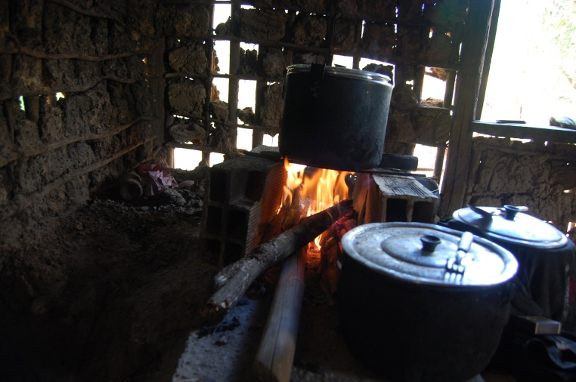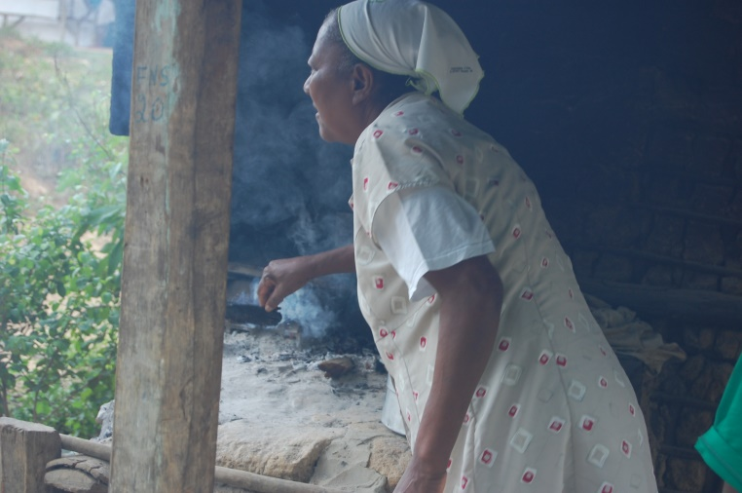

**.**

**Rudimentary stoves burn excessive wood and create unhealthful homes**

This is exactly the case in rural NE Brazil, where cooking is performed over open fires, most often built on the

dirt floor of the kitchen or on the ground outside. Stones or bricks are used to support the pot. Chimneys are non-existent.

1. the project stove is a single pot or multi pot portable or an in situ cookstove with a specified efficiency of at least 20%.

The project stove is a robust 2-burner stove equipped with combustion chamber, insulation, chimney and fuel shelf designed in partnership with Aprovecho Research Center. Efficiency tests were carried out by Aprovecho in March 2014. The result was a thermal efficiency of 20.1%. A NEW WATER BOILING TEST WITH 3 RUNS PERFORMED ON 3 RANDOMLY-SELECTED PROJECT STOVES WILL BE SUBMITTED AT FIRST VERIFICATION. Water Boiling Test performed by EcoTech Consultoria Ambiental in October 2017. Report and spreadsheet presented in Annex 3.

1. The project boundary can be clearly identified, and the cookstoves counted in the proposed project activity are not included in any other voluntary market or CDM project activity (i.e. no double counting takes place). The project proponent must have a mechanism in place together with appropriate mitigation measures to prevent double counting.

The cookstoves to be installed are exclusive to project GS6050. Double-counting is avoided by uniquely identifying each stove through a series of data points in the Project Database, these being:

* Full Name
* *RG – Registro Geral*, or national identification number, of the stove beneficiary –Note: the Database field RG does not permit repeat entries, therefore it is ensured that no two stoves can be owned by the same person
* Community and Municipality
* GPS Location
* Unique stove serial number automatically assigned by Microsoft Access
* Terms of Authorization contract signed by each stove owner

The project boundary is clearly defined to be the municipalities of Cruz das Almas and Nazaré, of the Recôncavo Region.

* + 1. The project proponent must clearly communicate if the entity is claiming the ownership rights to sell the emission reductions resulting from the project activity. This must be communicated to the cookstoves producers, retailers and end users by contract or clear written assertions in the transaction paperwork.

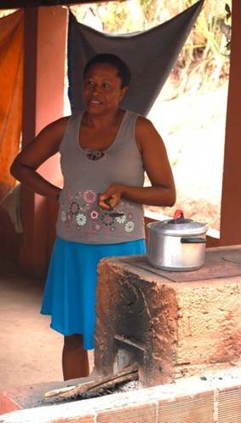The transfer of ownership of credits is made transparent through written contracts. Each project beneficiary signs a contract, the terms of the Authorization and Transfer of Carbon Credits Rights, transferring the ownership rights to the carbon credits to Instituto Perene. The cookstove end-users are fully aware of and willing to give up their rights on emission reductions, and this has been documented through video footage of the stakeholder meetings. The text of the Agreement is below:

1. The use of the baseline cookstove, as a backup or auxiliary technology, in parallel with the improved cookstove introduced by the project activity is permitted as long as a mechanism is put into place to encourage the removal of the old cookstove (e.g. a discounted price for the improved cookstove) and there is a definitive discontinuity of its use.

Experience in the previous 7,000 households benefitted by Perene cookstove projects has shown that baseline stove use is extremely rare once the efficient cookstove has been installed. Mechanisms to discourage baseline use include: dismantling of the baseline stove during construction, frequently the new stove is built on top of the old stove location, frequent monitoring visits to observe stove use pattern. Reality shows, however, that stove users avoid returning to baseline stove use mainly out of a strong preference for the new stove, which which use less wood, lead to significantly cleaner air in the home and are much more comfortable to cook on as they are elevated, whereas traditional stoves are on the ground and cooks have to bend over to add fuel, stir food, place and remove pots. Monitoring surveys include a question about baseline stove use, and it has been consistenly found that baseline use, with few exceptions, only occurs in the same households in which the project stove is no longer operating. Parallel use of baseline stoves and project stoves has been very low – generally less than 3% (refer to Monitoring Reports GS 832 and GS 1028).

.

* + 1. Project boundary

>> *(Present a flow diagram of the project boundary, physically delineating the project, based on the description provided in section A.5 above.)*

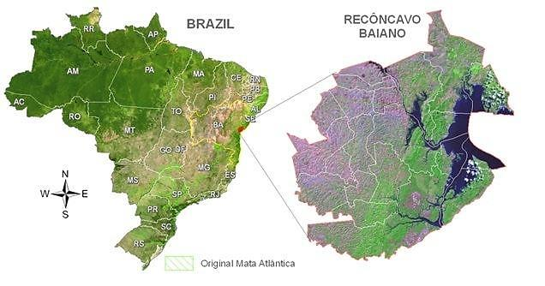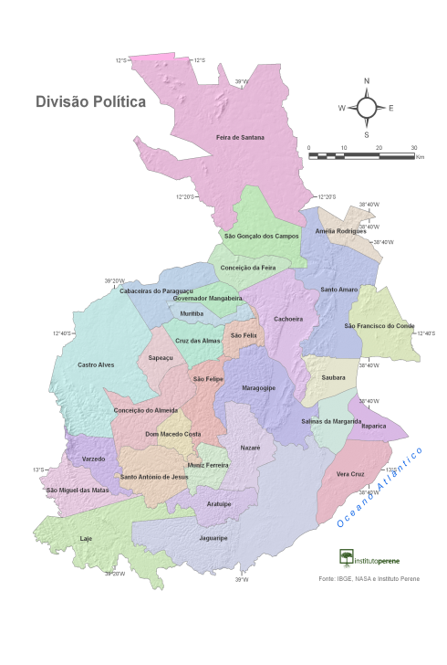

**Project Boundary**

**Original Atlantic Forest**

**RECÔNCAVO REGION**

* + 1. Establishment and description of baseline scenario

>> *(Explain how the baseline scenario is established in accordance with guidelines provided in GS4GG Principles & Requirements and the selected methodology(ies). In case suppressed demand baseline is used then same should be explained and justified.)*

The baseline is the use of inefficient, rudimentary cookstoves that burn non-renewable biomass for fuel. No changes to the baseline are expected in the project region for the next 10 years. The region has been economically stagnant for decades and no major changes have occurred over the past decades to the cooking practices of local residents. Therefore, the baseline is fixed.

Baseline fuel consumption was determined according to “Option a: Historical data” of the Simplified Methodology for Efficient Cookstove, p. 5. The methodology states that: “for option (a), the project proponents need to make sure that historical data is relevant to the target population and appropriately justified.”

The baseline applied in this project is the same that was approved in 2015 for projects GS832 and GS1028, and applies the Gold Standard Simplified Methodology for Efficient Cookstove, option a: Historical data method for determining baseline fuel consumption. Historical annual fuelwood consumption was determined to be:

**4.2 tons of wood/HH**

Historical data was obtained from Bahia state Energy report, published by the government of Bahia, as well as a study prepared by Winrock International and the Shell Foundation.

The 2007 Winrock/Shell report, entitled Brazil Market Analysis for Improved Stoves, submitted as supporting document to the GS 1028\_Request to Revise Baseline Fuelwood Consumption, is not accessible online and was finally obtained by Perene by personally contacting Rogerio Carneiro de Miranda, Project Coordinator of the work. The document is very pertinent as it contains wood-burning household data specific to Bahia, the project home state. As it is the most thorough and relevant document on the subject, Perene used it as the source for the quantity of domestic wood-burning households in the baseline study. The excerpted table is presented below:

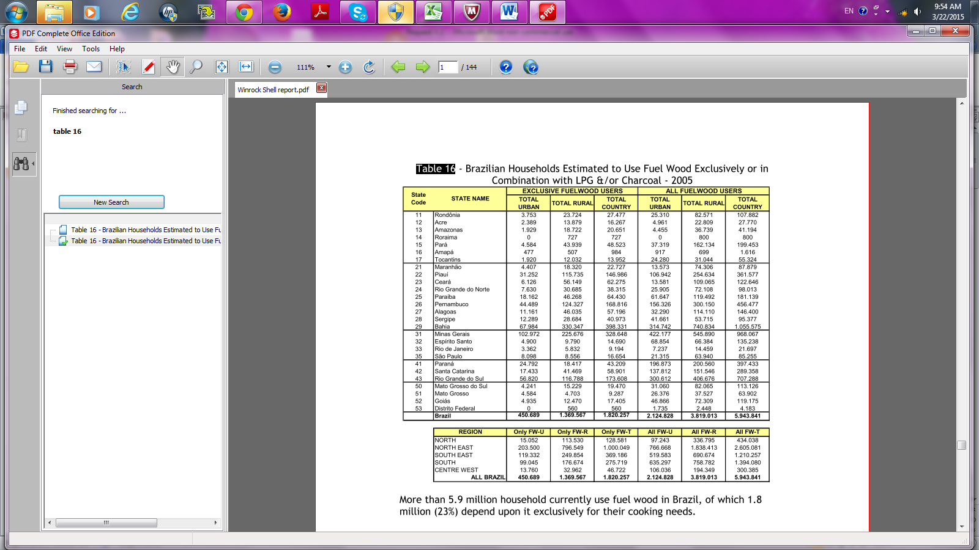

From the table above, Bahia state had 1,055,575 households using fuelwood as a domestic fuel. This includes both households that use wood exclusively, as well as households that use wood in combination with LPG or charcoal.

Having the above household information pertaining to Bahia, Perene sought to locate consumption data also specific to the state and the same year. Contact was made by telephone with Aldo de Freitas Pinheiro, Energy Development Coordinator of the Secretariat of Infrastructure of the state of Bahia, responsible for coordinating the *Balanço Energetico da Bahia*, or Bahia Energy Report. From Mr. Pinheiro, Perene learned that residential fuelwood use for the state was reported in the *Balanço Energetico da Bahia*, a state-level version of the national report *Balanço Energetico Nacional*. Perene was able to obtain the latest version (2014) and discuss the information with Mr. Pinheiro.

The table below, from Bahia’s *Balanco Energetico 2014* (SEINFRA BA, 2014)*,* shows domestic household fuelwood consumption of 1,383 x 103 TOE (ton of oil equivalent – tep in Portuguese) for the same year as the household data of the Winrock-Shell study.

Converting 1,383,000 TOE to tons of fuelwood by the conversion rate[[1]](#footnote-1) of 0.31 TOE/ton wood, results in 4,461,290 tons of fuelwood. Dividing the amount of residential firewood used in Bahia by the number of households using firewood in the same state and year yields:

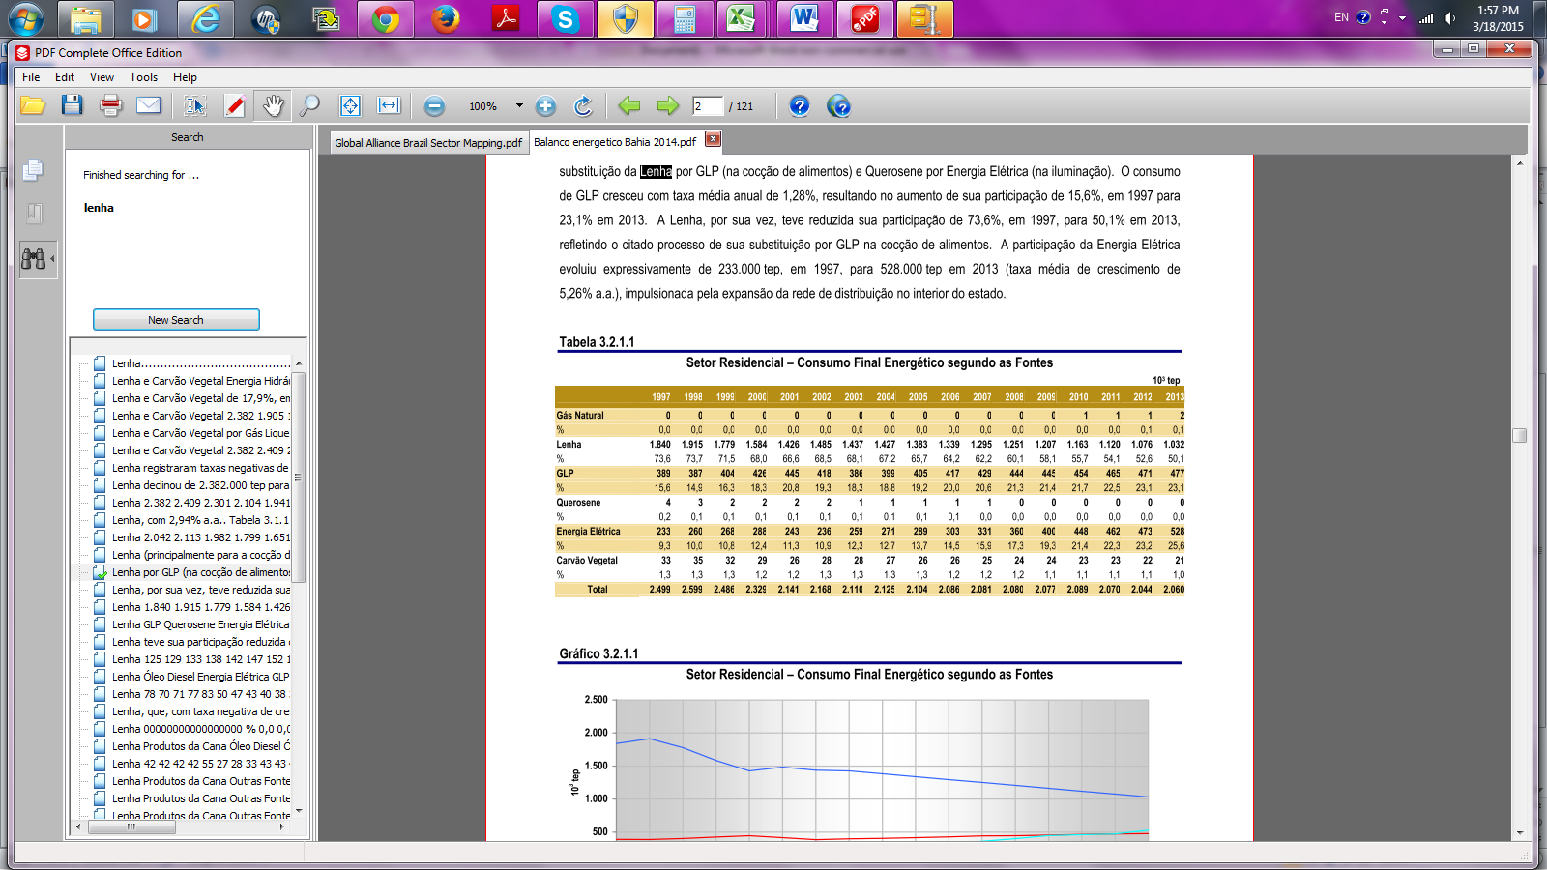

4,461,290 tons of wood /1,055,575 HH = **4.2 tons of wood/HH**

Source: SEINFRA 2014

This value is conservative when compared to values obtained from using other sources, as summarized in the table below. The exception is source number 3, International Energy Agency, which was initially proposed by Perene but considered by the Gold Standard review team to be too broad in scope to be relevant.

|  |  |  |
| --- | --- | --- |
| **Baseline Annual Fuelwood Use for Households in Brazil – Comparison of Values of Historical Usage** | | |
|  | **Source** | **Tons wood/HH** |
| Adopted Baseline | SEINFRA/Winrock-Shell 2005 | 4.2 |
| Alternative 1 | GACC 2011 / CEMIG | 5.7 |
| Alternative 2 | MME 2010 / IBGE | 8.5 |
| Alternative 3 | IEA 2006 / IBGE | 3.9 |
| Alternative 4 | KPT 2012 | 4.8 |
| Alternative 5 | SEINFRA/Winrock-Shell  Extrapolated to 2012 | 5.8 |

Relevance of Historical Data to Target Population

The historical data presented is directly applicable to the target population because it is specific to the state of Bahia in which the project will take place. Bahia has the largest concentration of rural poor in Brazil, characterized by “traditional factors, such as the existence of mini-fundios with limited land, lack of capital and access to credit and lack of access to markets” (de Castro, 2011, p. 15). The Winrock/Shell Study is uniquely applicable in that it captures the stove stacking that occurs throughout the target region, with use of both wood and LPG gas – most government studies fail to address the existence of multiple stoves in the same household. If basline calculations were to be done considering housholds which ONLY use fuelwood, the resulting baseline use would be much higher and would not reflect the reality that the fuel needs are being partially met with LPG.

Although more recent data is available on total wood consumption for domestic cooking, the latest data available on the number of households consuming fuelwood is from 2005. During the Gold Standard review process of the historical baseline study carried out for GS832 and GS1028, it was requested that the household data be extrapolated to 2012, in order to compare this with the 2012 consumption data. The resulting value was in fact higher, as shown in Alternative 5 in the table above.

It is interesting to note that in recent years, most likely due to the economic recession that began to seriously affect Brazil in 2013, there has been a reversal in the trend of residential sector demand for firewood, which registered an increase in both 2014 and 2015, as shown in the table below, extracted from the Energy Balance Report (Ministry of Mines and Energy, 2016, p. 79)

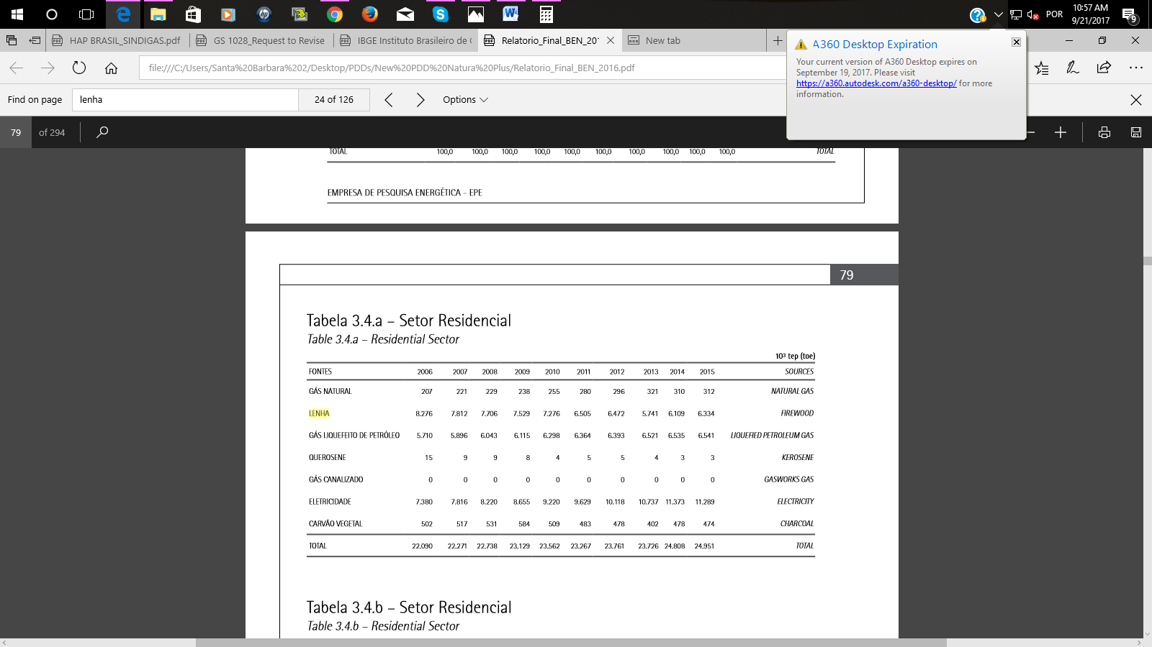

* + 1. Demonstration of additionality

>> *(If the proposed project is not a type of project that is deemed additional, as stated below, then follow guidelines in section 3.5.1 of GS4GG Principles & Requirements to demonstrate additionality.)*

The table below is only applicable if the proposed project is deemed additional, as defined by the applied approved methodology or activity requirement or product requirement.

| Specify the methodology or activity requirement or product requirement that establish deemed additionality for the proposed project (including the version number and the specific paragraph, if applicable). | The Gold Standard Micro-scale Scheme Rules, p 3 under Item 7. Additionality: Regular cycle activities that meet any one of the criteria defined below (and meet the eligibility requirements under section 1) shall be deemed additional:  iii. The project activity is located in any host country different from the countries defined above but PPs can demonstrate that project implementation will essentially benefit poor communities. No specific definition of ‘poor communities’ is pre-established. The Millennium Development Goals-based long term National Development Strategy (NDS) can serve as the basis to assess the eligibility of the targeted communities. PPs shall seek approval from the Gold Standard Foundation on the basis of a formal request providing detailed argumentation as to how the activity benefit poor communities.  AND  vi. The project activity is an emission reduction project in which each of the independent subsystems / measures achieve annual emission reductions equal to or less than 600 tCO2 or **annual energy savings equal to or less than 600 MWh** or installed capacity is less than 1500 kW for households/ SMEs/ communities. |
| --- | --- |
| Describe how the proposed project meets the criteria for deemed additionality. | iii. The project will benefit rural villagers in Bahia, a population which is characterized as “extremely poor” (monthly income of less than US$35) and “poor” (monthly income US$35-65) according to the Brazilian federal government, through the Institute of Applied Economic Research, in its special report entitled Profile and Evolution of Poverty in Bahia State 2004-2009 (de Souza, 2012)  vi: Each of the cookstoves is expected to save approximately 7.2 MWh/year, well below the 600MWh annual limit to be considered additional under the Micro-scale rules.  Approximately 2 tons wood saved/HH annually, average energy content of 0.31 TOE/ton[[2]](#footnote-2) wood, converted to MWh 1 TOE = 11.62 MWh  2 tons/HH \* 0.31 TOE/ton \* 11.62 MWh/TOE = 7.2 MWh saved/HH annually |

* + 1. Sustainable Development Goals (SDG) outcomes
       1. Relevant target for each of the three SDGs

>> *(Specify the relevant SDG target for each of three SDGs addressed by the project. Refer most recent version of targets* [*here*](http://www.un.org/sustainabledevelopment/sustainable-development-goals/) *.)*

* SDG 13. CLIMATE ACTION. TARGET: Improve education, awareness-raising and human and institutional capacity on climate change mitigation, adaptation, impact reduction and early warning

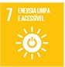

* SDG 7 TARGET: By 2030, double the global rate of improvement in energy efficiency
* SDG 1 TARGET: By 2030, ensure that all men and women, in particular the poor and the vulnerable, have equal rights to economic resources, as well as access to basic services, ownership and control over land and other forms of property, inheritance, natural resources, appropriate new technology and financial services, including microfinance

Explanation of methodological choices/approaches for estimating the SDG outcome

>> *(Explain how the methodological steps in the selected methodology(ies) or proposed approach for calculating baseline and project outcomes are applied. Clearly state which equations will be used in calculating net benefit.)*

**SDG 13. Climate Action**

Impact on Climate Action is calculated by applying GS Simplified Cookstove Methodology, p. 5, equation (1):

**ERy = ∑NP,y \* Py \* UP,y \*(fNRB,y \* EFb,fuel,CO2 + EFb,fuel,non \_ CO2)\*(1−DFb,Stove,y )**

Where:

NP,y Number of project cookstoves of each age group operational in the year y

Py Quantity of firewood that is saved in the year y (tonnes per household in year y)

UP,y Usage rate for project cookstoves in year y, based on adoption rate and drop off rate revealed by usage surveys (fraction)

fNRB,b,y Fraction of biomass, used in year y for baseline scenario, which can be established as non-renewable. .

EFb,fuel,CO2 CO2 emission factor of firewood that is substituted or reduced.

EFb,fuel,non\_CO2 NonOCO2 emission factor of firewood that is substituted or reduced.

DFb,Stove,y Usage of baseline cookstove during the year y (fraction) in project scenario

x y – 1

y Year of the crediting period

Py ,Quantity of firewood that is saved in the year y, is calculated according to GS Simplified Cookstove Methodology, p. 5, equation (2)

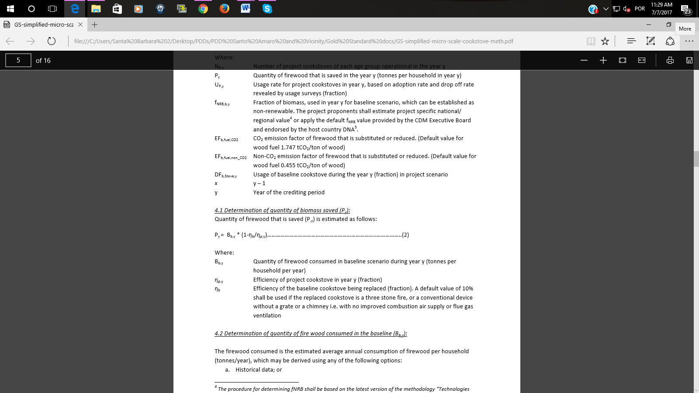

**SDG 7. Affordable and Clean Energy.**

To calculate the impact on energy efficiency, the project applies a default baseline efficiency and an independently-tested project efficiency.

The baseline stove is the traditional, rudimentary stove used throughout rural Bahia, which consists of fire built on the ground with loose rocks or local bricks serving as support for the pot. These cooking fires are not equipped with a chimney, fuel shelf, combustion chamber, insulation or any other improvements. For the baseline energy efficiency, the value used is the default contained in the GS Simplified Cookstove Methodology, p. 5, which states:

*A default value of 10% shall be used if the replaced cookstove is a three stone fire, or a conventional device without a grate or a chimney i.e. with no improved combustion air supply or flue gas ventilation.*

Typical Stoves in the Project Region - Baseline Three-Stone Fire

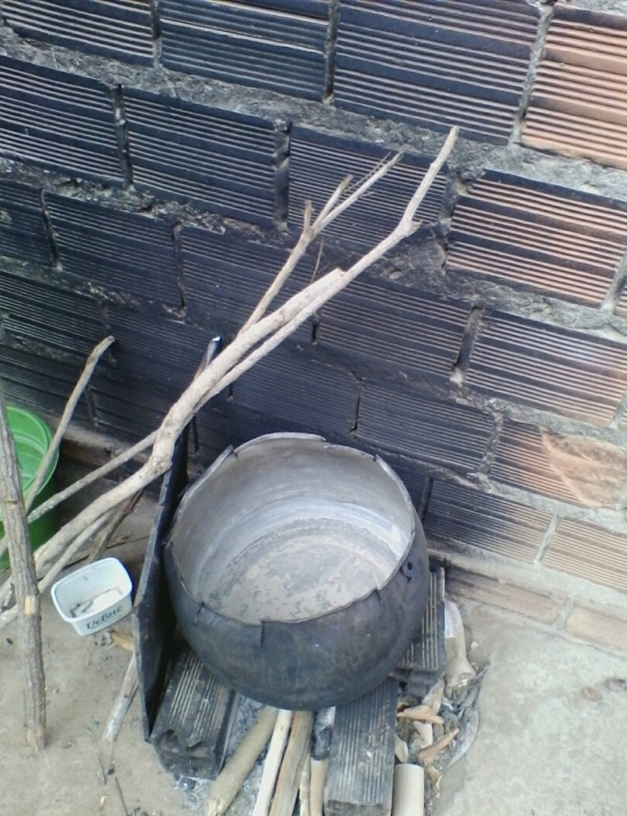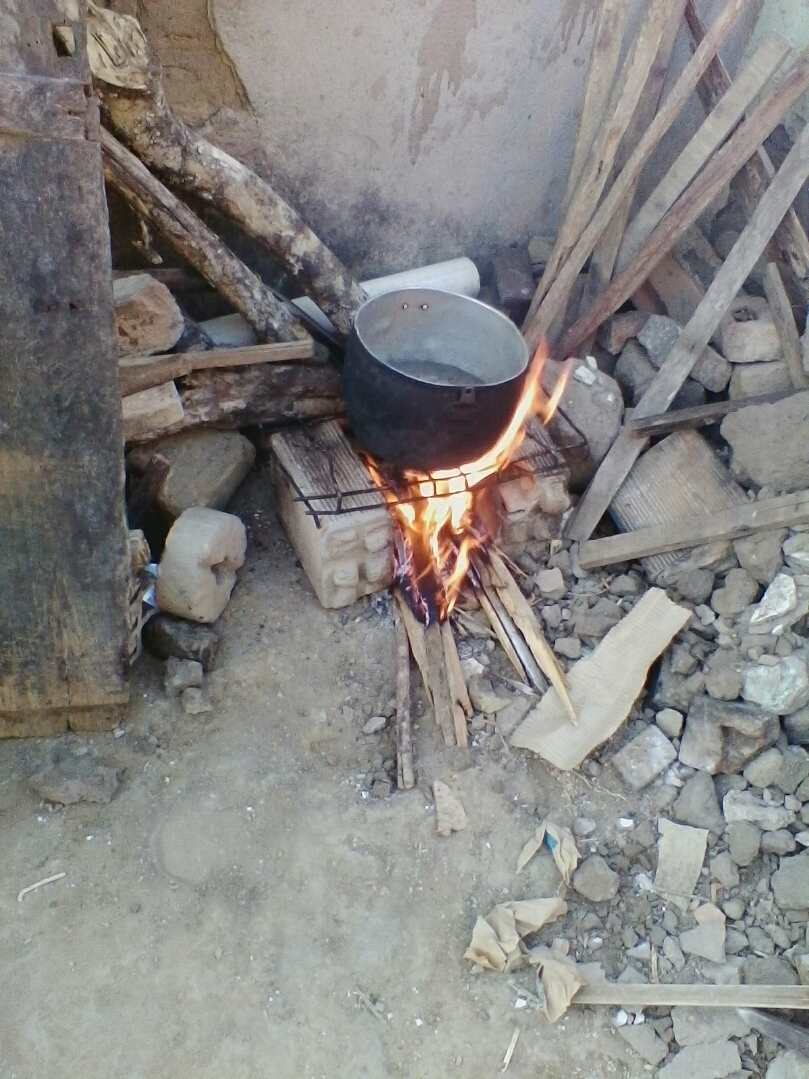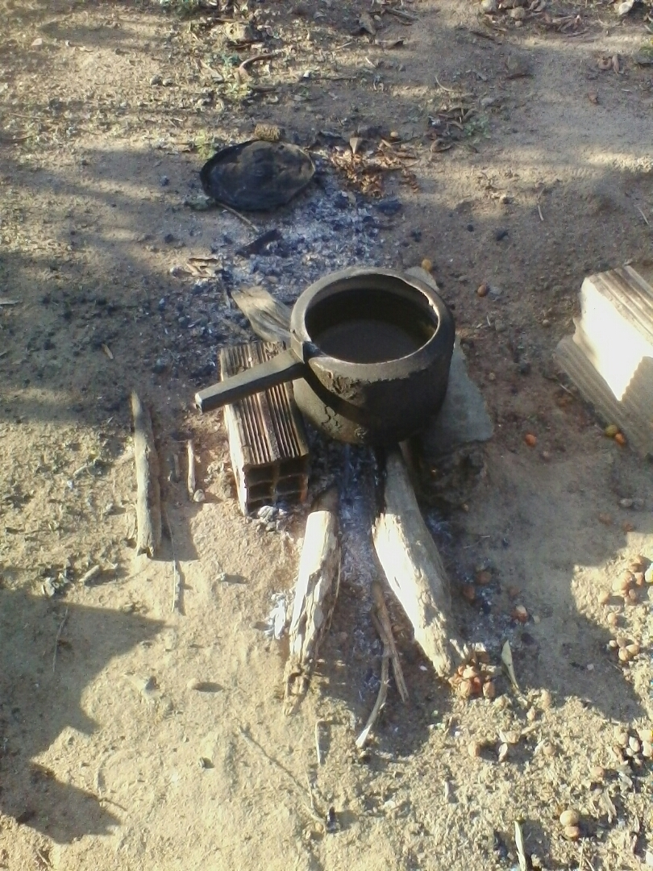

The project efficiency is determined per GS Simplified Cookstove Methodology, p. 7

*The efficiency of the project cookstove needs to be determined by an independent expert or entity, in the field or laboratory, following the Water Boling Test protocol (available at <*[*http://www.pciaonline.org/node/1048*](http://www.pciaonline.org/node/1048)*>). To determine the project cookstove efficiency, three sample runs shall be carried out on at least three randomly selected project cookstoves. The average of the nine results shall be taken as the efficiency for the project cookstove (np).*

The WBT report is included in Annex 3.

**SDG 1. No Poverty**

Impact assessment on SDG 1 follows the Microscale Methodology for Improved Cookstoves Version 1.0 sampling size and monitoring methodology to determine the number of households and total persons benefitting from access to basic services and appropriate new technology, on an annual basis.

* + - 1. Data and parameters fixed ex ante for monitoring contribution to each of the three SDGs

(Include a compilation of information on the data and parameters that are not monitored during the crediting period but are determined before the design certification and remain fixed throughout the crediting period like IPCC defaults and other methodology defaults. Copy this table for each piece of data and parameter.)

|  |  |
| --- | --- |
| **Relevant SDG Indicator** | **SDG 13. Climate Action** |
| **Data/ Parameter** | EFb,fuel,CO2 |
| **Data Unit:** | tCO2/t of firewood |
| **Description:** | CO2 emission factor arising from use of firewood in baseline scenario |
| **Source of data:** | IPCC default values, table 1.4 of chapter 1 of Vol. 2, 2006 IPCC Guidelines for National Greenhouse Gas Inventories |
| **Value(s) applied** | 1.747 tCO2/t of firewood |
| **Choice of data or Measurement methods and procedures** | IPCC default values |
| **Any comment:** |  |
|  | |
| **Relevant SDG Indicator** | **SDG 13.** Climate Action |
| **Data/ Parameter** | EFfuel,non-CO2 |
| **Data Unit** | tCO2/t of firewood |
| **Description** | Non-CO2 emission factor arising from use of firewood in baseline scenario |
| **Source of data** | IPCC default values, Table 2.9 of Chapter 2 of Vol. 2, 2006 IPCC Guidelines for National Greenhouse Gas Inventories |
| **Value(s) applied** | 0.455 tCO2/t of firewood |
| **Choice of data or Measurement methods and procedures** | IPCC default values |
| **Any comment:** |  |
|  | |
|  | |
| **Relevant SDG Indicator** | **SDG 13.** Climate Action |
| **Data/ Parameter** | fNRB,y |
| **Data Unit** | Fractional non-renewability |
| **Description** | Non-renewability status of wood fuel during year y |
| **Source of data** | The NRB fraction used for this project has been determined from the results of the NRB study conducted in 2012 for the Project Efficient Cookstoves in the Bahian Recôncavo Region (GS832), validated in May 2013. In order to be conservative, the lower of the NRB values determined by the NRB studies commissioned by Instituto Perene is used in this PDD.  The table below shows the source used for each variable in the calculation of the non-renewable biomass fraction.   |  |  | | --- | --- | | **Parameter** | **Source** | | MAI - Mean Annual Increment (forest growth) | Siqueira 2007 | | Fuel Collection Areas | Falieri 2011 | | H – Total Annual Harvest (forest loss) | Falieri 2011 | | Total Forest Stock | Metzker et al 2009 |   *Fuel Collection Areas* and *Total Annual Harvest* values were obtained from the NRB study (Falieri, 2011) |
| **Value(s) applied** | 0.81 |
| **Choice of data or Measurement methods and procedures** | The fraction of NRB was determined according to the Gold Standard Methodology,  fNRB = (NRB/H)  NRB = H – MAI  Where:  NRB is the non-renewing biomass or excess harvest.  H is the total annual harvest of woody biomass from the fuel collection areas;  MAI is the sum of mean annual increments of the wood species.  The result of applying this analysis is: 0.81 |
| **Purpose of data** | To determine what fraction of the biomass burned is non-renewable and therefore contributes to emissions reductions. |
| **Any comment:** | The NRB fraction used for this project has been determined from the results of the NRB study conducted in 2012 for the Project Efficient Cookstoves in the Bahian Recôncavo Region (GS 832), validated in May 2013. The area of study of both PDDs is the Bahian Recôncavo, in eastern Bahia state, in a radius of 100 km from the city of Salvador. Studies show a territory with similar physical, cultural and historical characteristics. According to Alessandra Oliveira from the Feira de Santana State University in her paper entitled “Territorial Dynamics of the Recôncavo Baiano” this region is one of oldest territorial occupations in Brazil. According to this study, the Recôncavo Baiano was one of the first areas occupied by the Portuguese in Brazil (starting in the 1700s), presenting since the beginning intense and homogeneous spatial modification” (Oliveira, 2010) |
|  | |
| **Relevant SDG Indicator** | **SDG 13. Climate** Action |
| **Data/ Parameter** | Bb,y |
| **Data Unit** | Tons of firewood per household per year |
| **Description** | Firewood consumption for cooking in the baseline |
| **Source of data** | **Historical data on** HH fuelwood consumption for the state of Bahia, Brazil presented in section B.4, from the sources:  Global Alliance for Clean Cookstoves. (2011). Brazil Feasibility Study.  Ministry of Mines and Energy of Brazil. (2010). Balanço Energetico Nacional.  Pinheiro, A. d. (2015, March 16). Energy Development Coordinator. (R. E. Valladares, Interviewer) Salvador, Bahia, Brazil.  SEINFRA BA. (2014). Balanço Energetico da Bahia. State Government of Bahia, Secretariat of Infrastructure.  Winrock International - Shell Foundation. (2007). Brazil Market Analysis for Improved Stoves. |
| **Value(s) applied** | 4.2 |
| **Choice of data or Measurement methods and procedures** | Option 4. 2 a “Historical data” was applied. A survey of available historical data was realized (see Annex 2) and the most pertinent and local information was used to determine baseline household consumption. Household information was obtained from the report “Brazil Market Analysis for Improved Stoves” by Winrock International and the Shell Foundation (2007) and firewood consumption from the energy report “Balanco Energetico” by the Bahian state government. |
| **Any comment:** |  |

|  |  |
| --- | --- |
| **Relevant SDG Indicator** | **SDG 7. Affordable and Clean Energy** |
| **Data/ Parameter** | µb |
| **Data Unit** | Fraction |
| **Description** | Efficiency of the cookstove being used in the baseline scenario |
| **Source of data** | Microscale Methodology for Improved Cookstoves |
| **Value(s) applied** | 0.10 |
| **Choice of data or Measurement methods and procedures** | According to the methodology (p 5): “A default value of 10% shall be used if the replaced cookstove is a three stone fire, or a conventional device without a grate or a chimney i.e. with no improved combustion air supply or flue gas ventilation” |
| **Any comment:** | Traditional stoves in rural Bahia, Brazil are three-stone fires, assembled with a few bricks or rocks, generally on the ground. These are open-air fires with no chimney or any improved feature. |
|  | |
| **Relevant SDG Indicator** | **SDG 7. Affordable and Clean Energy** |
| **Data/ Parameter** | µp |
| **Data Unit** | Fraction |
| **Description** | Efficiency of the cookstove being used in the project scenario |
| **Source of data** | Water Boiling Test |
| **Value(s) applied** | 0.20 |
| **Choice of data or Measurement methods and procedures** | According to the cookstove methodology: “The efficiency of the project cookstove needs to be determined by an independent expert or entity, in the field or laboratory, following the Water Boling Test protocol (available at <http://www.pciaonline.org/node/1048>).” |
| **Any comment:** | A new water boiling test will be carried out before Verification I which will test 3 randomly selected project stoves, 3 times each, for a total of 9 test runs. The project stove efficiency applied for this parameter will be the average of the 9 efficiency values resulting from the WBTs. |

* + - 1. Ex ante estimation of outcomes linked to each of the three SDGs

>> *(Provide a transparent ex ante calculation of baseline and project outcomes (or, where applicable, direct calculation of net benefit) during the crediting period, applying all relevant equations provided in the selected methodology(ies) or as per proposed approach. For data or parameters available before design certification, use values contained in the table in section B.6.3 above. For data/parameters not available before design certification and monitored during the crediting period, use estimates contained in the table in section B.7.1 below)*

|  |  |  |  |
| --- | --- | --- | --- |
| SDG | Baseline | Project | Net Benefit |
| 13. Climate Action | See ER Calculations spreadsheet, Annex 1 to the PDD. | See ER Calculations spreadsheet, Annex 1 to the PDD. | 76,425 tons CO2e |
| 7. Affordable and Clean Energy | 10% thermal efficiency | 23.2% thermal efficiency | More than double energy efficiency of available cooking technology |
| 1. No Poverty | 0 families with access to new efficient cookstove technology | 3000 families with access to new efficient cookstove technology | 3000 families benefitted |

* + - 1. Summary of ex ante estimates of each SDG outcome

**SDG 13. Climate Action**

Ex-ante estimates are calculated using the Excel spreadsheet provided as part of the Simplified Cookstove Methodology:

401.13-ER-MS-CS-er\_calculation\_tool\_cookstove\_meth\_v2.00

The resulting ex-ante estimates are shown in the table below. Input and calculations are presented in Annex 1.

|  |  |  |  |
| --- | --- | --- | --- |
| **Emission reduction - Summary** | |  |  |
| Year | Emission reduction | Lekage adjustment | Net Emission reduction |
|  | tCO2/year | tCO2/year | tCO2/year |
| 2018 | 5396 | 0 | 5396 |
| 2019 | 10000 | 0 | 10000 |
| 2020 | 9705 | 0 | 9705 |
| 2021 | 9170 | 0 | 9170 |
| 2022 | 8538 | 0 | 8538 |
| 2023 | 7918 | 0 | 7918 |
| 2024 | 7309 | 0 | 7309 |
| 2025 | 6711 | 0 | 6711 |
| 2026 | 6126 | 0 | 6126 |
| 2027 | 5552 | 0 | 5552 |
|  |  |  |  |
| Total |  |  | 76425 |
| Annual emission reduction |  |  | 7642 |
|  |  |  |  |
|  |  |  |  |

**SDG 7. Improving energy efficiency**

The *ex-ante* ER estimates were calculated using the default baseline efficiency of 10%, as defined in the GS Simplified Cookstove Methodology and project efficiency of 20%, which has already been applied in two similar projects - GS832 and GS1028. The current project will use the same stove model as Perene´s previous cookstove projects.

**SDG 1. No Poverty**

The *ex-ante* estimate of impact on Poverty is 3,000 new cookstove owners with increased service to basic energy service and new technology. Data will be gender-segregated and estimates are as follows:

3,000 new stove owners x 80% female = 2,400 female stove owners

3,000 new stove owners x 20% male = 600 male stove owners

The percentages of stove owners being 80% women and 20% men is applied considering the average values determined for Perene´s two verified projects GS832 and GS1028 which are in similar target region, population and the same cookstove model.

* + 1. Monitoring plan
       1. Data and parameters to be monitored

(Include specific information on how the data and parameters that need to be monitored in the selected methodology(ies) or proposed approaches or as per mitigation measures from safeguarding principles assessment or as per feedback from stakeholder consultations would actually be collected during monitoring. Copy this table for each piece of data and parameter.)

|  |  |
| --- | --- |
| **Relevant SDG Indicator** | **SDG 13. Climate Action** |
| **Data/ Parameter** | Up,y |
| **Data Unit** | Percentage |
| **Description** | Usage rate in project scenario p during year y, derived for each age group of project cookstove being credited. |
| **Source of data** | Annual usage survey/Monitoring survey. |
| **Value(s) applied** | |  |  | | --- | --- | | age-group | Usage rate | | 0\_1 | 97% | | 1\_2 | 93% | | 2\_3 | 90% | | 3\_4 | 85% | | 4\_5 | 80% | | 5\_6 | 75% | | 6\_7 | 70% | | 7\_8 | 65% | | 8\_9 | 60% | | 9\_10 | 55% | |
| **Choice of data or Measurement methods and procedures** | The Survey follows the sample survey referenced in Annex A of GS Simplified Cookstove Methodology. In accordance with the methodology, the survey is conducted following simple random sampling approach and the minimum sample size is determined as per the guidelines below;   * Project target population < 300: Minimum sample size 30 * Project target population 300 to 1000: Minimum sample size 10% of group size * Project target population > 1000 Minimum sample size 100 |
| **Monitoring Frequency** | Annual |
| **QA/QC Procedures** | Surveys are carried out by a trained Perene technician, accompanied by a female Community Agent, in the home of the interviewee. Although door-to-door monitoring visits are far more costly than the telephone interviews allowed by the methodology, physical presence in the home allows direct observation of the stove, fuel and stove use patterns. Surveys responses are entered into a standard questionnaire using the QuickTapSurvey app on a hand-held digital device, and then synchronized via wi-fi to the Cloud. |
| **Purpose of Data** | To determine the adoption rate of the project stoves by project participants and to adjust the ER calculations accordingly. |
| **Any comment:** |  |

|  |  |
| --- | --- |
| **Relevant SDG Indicator** | **SDG 13. Climate Action** |
| **Data/ Parameter** | Np,y |
| **Data Unit** | Number of stoves |
| **Description** | Number of efficient wood-burning cookstoves constructed |
| **Source of data** | Project database, installation record, signed Terms of Agreement by each stove owner |
| **Value(s) applied** | |  |  | | --- | --- | | **Year** | **No of cookstoves constructed** | | 2018 | 1500 | | 2019 | 1500 | |
| **Choice of data or Measurement methods and procedures** | For each stove constructed, the following information is obtained:   1. photo is taken of each stove built 2. GPS location of HH 3. Beneficiary name, ID number, community and municipality 4. Signed Terms of Agreement |
| **Monitoring Frequency** | Monthly |
| **QA/QC Procedures** | The building team is trained in the use of the app program Fulcrum, which allows on-site data entry into a standard form on a hand-held digital device. All the information listed above is automatically synchronized via wi-fi to Perene´s Cloud Database. The Terms of Authorization, signed, dated and including the stove owner´s ID number and location are then mailed to Perene headquarters where a QC check by a Perene admin staff takes place, comparing the information on each Term to the information entered in Fulcrum. |
| **Purpose of Data** | To determine the number of stoves constructed in the period |
| **Any comment:** |  |

|  |  |
| --- | --- |
| **Relevant SDG Indicator** | **SDG 7. Energy Efficiency** |
| **Data/ Parameter** | DFn |
| **Data Unit** | Fraction |
| **Description** | Discount factor to account for efficiency loss of project cookstoves |
| **Source of data** | ER Calculation spreadsheet from Methodology |
| **Value(s) applied** | 1% efficiency loss per year |
| **Choice of data or Measurement methods and procedures** | Default discount factor stated by Gold Standard Simplified Cookstove Methodology |
| **Monitoring Frequency** | Annual |
| **QA/QC Procedures** | N/A as this is a default value provided by GS |
| **Purpose of Data** | To determine the efficiency loss over time of the project cookstoves and to reduce the ER accordingly |
| **Any comment:** |  |

|  |  |
| --- | --- |
| **Relevant SDG Indicator** | **SDG 13. Climate Action** |
| **Data/ Parameter** | DFP,stove,y |
| **Data Unit** | Fraction |
| **Description** | Discount factor to account for the baseline stove use in project scenario p during the year y |
| **Source of data** | Annual Monitoring Surveys |
| **Value(s) applied** | |  |  | | --- | --- | | **Year** | **Input value** | | 2018 | 3% | | 2019 | 3% | | 2020 | 3% | | 2021 | 3% | | 2022 | 3% | | 2023 | 3% | | 2024 | 3% | | 2025 | 3% | | 2026 | 3% | | 2027 | 3% | |
| **Choice of data or Measurement methods and procedures** | Discount factor is determined as fraction of stove users using both the baseline and project stoves, as determined by the Monitoring Surveys. A Query is performed on the survey data to cross-check the HH still using the baseline stove with HH still using the project stove: HH that satisfy both query criteria are totaled and the percentage relative to the entire sample size is calculated. This percentage of baseline use is then entered into the ER Excel calculation spreadsheet. |
| **Monitoring Frequency** | Annual |
| **QA/QC Procedures** | Baseline stove use is determined through a direct question on the Monitoring Survey as well as observation by the Community Agent and Perene technician during the HH visit. Mechanisms to discourage baseline use include: dismantling of the baseline stove during construction, building the new stove on top of the old stove location, frequent monitoring visits to observe stove use pattern. See Comment |
| **Purpose of Data** | To determine the percentage of project participants who continue to use the baseline stove after the new stove has been installed and to adjust ER accordingly. |
| **Any comment:** | Experience in the previous 7,000 households benefitted by Perene cookstove projects has shown that baseline stove use is extremely rare once the efficient cookstove has been installed. Although several steps are taken to discourage baseline stove use, reality shows, that stove users avoid returning to baseline stove use mainly out of a strong preference for the new stove, which use less wood, generate much less smoke and are much more comfortable to cook on as they are elevated, whereas traditional stoves are on the ground and cooks have to bend over to add fuel, stir food, place and remove pots. Parallel use of baseline stoves and project stoves has been very low – generally less than 3% (refer to Monitoring Reports GS 832 and GS 1028). |

|  |  |
| --- | --- |
| **Relevant SDG Indicator** | **SDG 1. No Poverty** |
| **Data/ Parameter** | HH |
| **Data Unit** | Number of households |
| **Description** | Number of households benefitting by owning an efficient cookstove for each year of operation of the project. Numbers are not cumulative. |
| **Source of data** | Project database, installation record, signed Terms of Agreement by each stove owner, Monitoring surveys. The numbers are calculated by the ER Calculations Excel spreadsheet of the Microscale Methodology for Improved Cookstoves Version: 1.0 |
| **Value(s) applied** | |  |  | | --- | --- | | Year | HH in operation\_adjusted for usage rate annually | | 2018 | 1455 | | 2019 | 2850 | | 2020 | 2745 | | 2021 | 2625 | | 2022 | 2475 | | 2023 | 2325 | | 2024 | 2175 | | 2025 | 2025 | | 2026 | 1875 | | 2027 | 1725 | |
| **Choice of data or Measurement methods and procedures** | For each HH benefitted, the following information is obtained:   1. photo is taken of each stove built 2. GPS location of HH 3. Beneficiary name, ID number, community and municipality 4. Signed Terms of Agreement |
| **Monitoring Frequency** | Annually |
| **QA/QC Procedures** | The building team is trained in the use of the app program Fulcrum, which allows on-site data entry into a standard form on a hand-held digital device. All the information listed above is automatically synchronized via wi-fi to Perene´s Cloud Database. The Terms of Authorization, signed, dated and including the stove owner´s ID number and location are then mailed to Perene headquarters where a QC check by a Perene admin staff takes place, comparing the information on each Term to the information entered in Fulcrum. Monitoring surveys are carried out annually to determine adoption rate and baseline use rate, on a randomly selected sample according to the methodology´s sample size requirements. |
| **Purpose of Data** | To determine the number of families and individuals benefitting from a reduction in poverty by means of access to improved basic energy services and appropriate new technology. |
| **Any comment:** |  |

|  |  |
| --- | --- |
| **Relevant Indicator** | **Safeguard** **Principle 3-Community Health, Safety and Working Conditions** |
| **Data/ Parameter** | Percentage of stove construction workers in project |
| **Data Unit** | % |
| **Description** | Percentage of stove construction workers trained and equipped with personal protective equipment |
| **Source of data** | Invoices of personal protective equipment for each worker. |
| **Value(s) applied** | 100% of workers covered. |
| **Choice of data or Measurement methods and procedures** | Copies of invoices of personal equipment purchased for team use, description of site visits, including photographs of stove construction underway, included in Monitoring Report. |
| **Monitoring Frequency** | Annually |
| **QA/QC Procedures** | To ensure that the protective equipment is in use by the team, Perene directors will report on periodic site visits to confirm that workers have and are using equipment correctly. |
| **Purpose of Data** | To ensure that workers are provided with the appropriate safety equipment to prevent injury on-site and help ensure safe working conditions for all the stove construction team. |
| **Any comment:** |  |

|  |  |
| --- | --- |
| **Relevant Indicator** | **Safeguard** **Principle 6-Economic Impacts** |
| **Data/ Parameter** | Percentage of project field and admin members who are working legally |
| **Data Unit** | % |
| **Description** | Percentage of Perene workers, including stove construction, office and Community Agent team members, who are over 18 years old. |
| **Source of data** | Government-issued ID known as *Registro Geral* |
| **Value(s) applied** | 100% of team members |
| **Choice of data or Measurement methods and procedures** | Copies of IDs will be obtained and kept on file by Perene, and included in the annual Monitoring Report. |
| **Monitoring Frequency** | Annually |
| **QA/QC Procedures** | The government-issued ID contains the person´s full name and date of birth, making it a simple matter to determine the person´s age and ensure that only those 18 years of age or older participate. |
| **Purpose of Data** | To ensure that the International Labor Organization, as well as Brazil´s national labor laws, are respected and that no child labour, as defined by the ILO Minimum Age Convention, is involved in the project. |
| **Any comment:** |  |

* + - 1. Sampling plan

>> *(If data and parameters monitored in section B.7.1 above are to be determined by a sampling approach, provide a description of the sampling plan.)*

From the Simplified Cookstove Methodology, p. 9:

Monitoring shall consist of checking of a representative sample, once every year (annually) to ensure that project cookstoves are still operating by carrying out the usage survey as per the guidelines below.

A usage survey must be conducted to estimate the drop off rates as project cookstove may not be adopted or may be disposed of and potentially replaced again by a baseline stove. Prior to the verification, a usage survey for each cookstove age-group is required. For example, if only cookstoves in the first year of use (age0\_1) are being credited, a usage parameter must be established for age- group 0-1, through a usage survey for cookstove age0\_1. If cookstoves of age 0-1 and age 1-2 are being credited (as part of first request for issuance), usage parameters must be established for age-group 0 -1 and 1-2, respectively through a usage survey. If cookstoves of age-group 0-1 and age-group 1-2 are being credited (as part of second request for issuance), usage parameter must be established for age- group 1-2 only through a usage survey as the usage rate for cookstoves of age group 0-1 can be applied from the previous issuance.

To successfully conduct a usage survey, the minimum project cookstove sample size of each age- group should be in line with the guidelines provided in section 4.2 option b.

From the Simplified Cookstove Methodology, p. 7:

Sample surveys should be conducted following simple random sampling approach and the minimum sample size should be determined as per the guidelines below;

* Project target population < 300: Minimum sample size 30
* Project target population 300 to 1000: Minimum sample size 10% of group size
* Project target population > 1000 Minimum sample size 100
  + - 1. Other elements of monitoring plan

Monitoring surveys will be carried out annually for each stove-age group separately for the length of the crediting period in accordance with the Monitoring guidelines contained in the Simplified Cookstove Methodology V 1.0. Monitoring sample groups and sizes are defined in the table below. The first monitoring period will begin in October 2018. Subsequent monitoring survey scheduling will be reported prior to each verification.

|  |  |  |  |  |  |
| --- | --- | --- | --- | --- | --- |
| **Year** | **No. of cookstoves installed** | **Stove Age-Groups Monitored** | **Sample Size for each Age-Group** | **Total HH Surveyed** | **Monitoring Period** |
| 2018 | 1500 | 0-1 | 100 | 100 | Oct-Dec 2018 |
| 2019 | 1500 | 0-1, 1-2 | 100 | 200 | Jan-Dec 2019 |
| 2020 | 0 | 1-2, 2-3 | 100 | 200 | Jan-Dec 2020 |
| 2021 | 0 | 2-3, 3-4 | 100 | 200 | Jan-Dec 2021 |
| 2022 | 0 | 3-4, 4-5 | 100 | 200 | Jan-Dec 2022 |
| 2023 | 0 | 4-5, 5-6 | 100 | 200 | Jan-Dec 2023 |
| 2024 | 0 | 5-6, 6-7 | 100 | 200 | Jan-Dec 2024 |
| 2025 | 0 | 6-7, 7-8 | 100 | 200 | Jan-Dec 2025 |
| 2026 | 0 | 8-9, 9-10 | 100 | 200 | Jan-Dec 2026 |
| 2027 | 0 | 9-10 | 100 | 100 | Jan-Dec 2027 |

The sample size applies to target populations above 1,000 households, in accordance with the methodology´s required sample size:

* Project target population > 1000 Minimum sample size 100

This minimum sample size applies to each stove age-group.

The Sampling Method is also in accordance with the methodology as households will be randomly selected from the project database, ensuring representative results. The project database is continually updated and contains all information pertaining to each stove installation (serial number, name, government-issued identification number, community, municipality, contact info, GPS location, installation date). The software used and random selection process will be reported in the monitoring report.

Regarding impact of daily and seasonal variations on the expected average fuel consumption savings:

the temperature and precipitation do not have significant variation over the year in this tropical region. Considerable rainfall occurs throughout all months of the year, with an annual average of 1780mm, and temperature varies between 21 °C and 29°C . [[3]](#footnote-3) Therefore there are generally no concerns over daily and seasonal variations affecting the fuel savings results.

Surveys are created using the program QuickTapSurvey and answers are entered by trained Perene technicians on a digital tablet. This system allows for collecting data offline in the remote communities and then uploading the results to the server when connected through wifi.

The Monitoring Survey is based on the Sample Survey Questionnaire contained in Annex A of the Microscale Methodology for Improved Cookstoves Version: 1.0, and consists of the following questions:

|  |  |  |  |
| --- | --- | --- | --- |
| MONITORING SURVEY QUESTIONS | | | |
| 1 | Date Collected | 25 | Location of project stove |
| 2 | Name of Interviewer | 26 | Do you use LPG? |
| 3 | Municipality | 27 | How often do you use the gas stove? |
| 4 | Community | 28 | What types of food do you cook on gas? |
| 5 | Name of Principal Stove User | 29 | How long does an LPG cylineder last? |
| 6 | ContractID | 30 | How much does an LPG cylinder refill cost? |
| 7 | Nickname | 31 | What do you think of the project stove? |
| 8 | Gender of Principal Stove User | 32 | Condition of the stove top |
| 9 | Total of adult residents | 33 | Condition of the chimney |
| 10 | Total of child residents | 34 | Condition of the combustion chamber |
| 11 | Main income source | 35 | Condition of the fuel shelf |
| 12 | Do you use wood to cook? | 36 | Wood consumption of project stove compared to old stove |
| 13 | Is the wood purchased or collected? (If purchased, go to 14) | 37 | Size of fuelwood for project stove compared to old stove |
| 14 | How much money do you spend on wood per month? | 38 | Time to collect fuelwood with project stove compared to old stove |
| 15 | Do you use the project stove? (If Yes, go to 16. If No, go to 17) | 39 | Smoke produced by project stove compared to old stove |
| 16 | How often do you use the project stove? | 40 | The indoor air with project stove compared to old stove |
| 17 | Why are you not using the project stove? | 41 | Cleanliness of pots and pans with project stove compared to old stove |
| 18 | What fuel do you use to cook beans? | 42 | Personal hygiene with project stove compared to old stove |
| 19 | What types of food do you cook on wood? | 43 | Redness of eyes with project stove compared to old stove |
| 20 | Is the stove in usable condition? | 44 | Cough with project stove compared to old stove |
| 21 | Is the stove top lifted and cleaned at least 1 x per week? | 45 | Allergies with project stove compared to old stove |
| 22 | Is the chimney cleaned at least 1 x per year? | 46 | Burns with project stove compared to old stove |
| 23 | Is the cover on the chamber removed and cleaned out at least 1 x per month? | 47 | Back pain with project stove compared to old stove |
| 24 | Do you still use the old wood stove? |  |  |

* 1. Duration and crediting period
     1. Duration of project
        1. Start date of project

>> *(Specify start date of the project, in the format of DD/MM/YYYY. Describe how this date has been determined as per the definition of start date provided in section 3.4.3 of GS4GG Principles & Requirements document and provide evidence to support this date.)*

01/04/2018 Although the initial start date was to be 01/01/2018, delays in the process have led the project start date to be revised to April 2018.

The event marking the start date will be the date on which the contract is signed with the local construction sub-contractor for the construction of the 3,000 stoves. A copy of the signed Contract will be submitted to Gold Standard.

* + - 1. This is in agreement with section 3.4.3 of GS4GG Principles & Requirements which states: “The Project start date shall be the earliest date on which the Project Developer has committed to expenditures related to the implementation of the Project." Furthermore: “Examples of start date may be the date on which contracts have been signed for equipment or construction/operation services required for the Project.” Expected operational lifetime of project

>> (*Specify in years)*

10 years

* + 1. Crediting period of project

10 years

* + - 1. Start date of crediting period

>> *(Specify in dd/mm/yyyy. This can be start of project operation or two years prior to the date of Project Design Certification, whichever is later.)*

01/04/2018 Although the initial start date was to be 01/01/2018, delays in the process have led the project start date to be revised to April 2018. The actual crediting period start date will depend on the date of Validation and consequent disbursement of funds by the funder.

The event that marks the start date of the crediting period is the start of stove installation, as evidenced by the Project Database, containing all pertinent information including date of installation, serial number and GPS location of the units constructed. In addition, payment invoices for services and parts will be submitted with each annual monitoring part as evidence of construction timeline.

* + - 1. Total length of crediting period

>> *(Specify the total length of crediting period sought in line with GS4GG Principles & Requirements or relevant activity requirements.)*

10 years

* 1. Safeguarding principles assessment
     1. Analysis of social, economic and environmental impacts

>> *(Refer the GS4GG Safeguarding Principles and Requirements document for detailed guidance on carrying out this assessment.)*

|  |  |  |  |  |
| --- | --- | --- | --- | --- |
| Safeguarding principles | Assessment questions | Assessment of relevance to the project (Yes/potentially/no) | Justification | Mitigation measure (if required) |
| SOCIAL & ECONOMIC SAFEGUARDING PRINCIPLES | | | | |
| **Principle 1-Human Rights** | a. The Project Developer and the Project shall respect internationally proclaimed human rights and shall not be complicit in violence or human rights abuses of any kind as defined in the Universal Declaration of Human Rights  b. The Project shall not discriminate with regards to participation and inclusion. | No | There is no risk of violence or abuse of human rights in this project. The project does not discriminate on gender, race, religion, sexual orientation or any other aspect. All rural dwellers of the project region who use wood as their primary cooking fuel, contribute the required bricks/cement, and sign the Terms of Agreement, are registered to participate in the project. | Not required |
| **Mandatory Requirements** | The Project Developer and the Project shall respect internationally proclaimed human rights and shall not be complicit in violence or human rights abuses of any kind as defined in the Universal Declaration of Human Rights | The PD and Project upholds the principles of accountability and the rule of law, participation and inclusion, and equality and non-discrimination. The construction team has been working for Perene for over five years and is made up of honest, hard-working local masons and helpers. Perene´s team is welcomed in all the communities as the team members are known for being respectful and attentive to their work. The same is true for the Community Agents, who are from the local population and undergo training and capacity-building. The work-day (8hrs), work-week (40 hrs), lunch-break (min. 30 min) and holiday policies (30 days/year) are aligned with Brazilian law 5452 **CONSOLIDAÇÃO DAS LEIS DO TRABALHO** http://www.planalto.gov.br/ccivil\_03/decreto-lei/Del5452.htm | | |
| The Project shall not discriminate with regards to participation and inclusion. | Project participants and construction team, Community Agents and administrative staff are of a rich diversity that reflects the population of Bahia, Brazil. The selection of the construction team and monitoring team members is always based on ability and availability and no questions asked regarding religion, beliefs, sexual orientation or any other personal factor. The only age requirement is being over 18 years old, complying with Brazilian and International law. The project benefits a wide range of ages, from children to the elderly. | | |
| **Principle 2-**  **Gender Equality and Women’s Rights** | Promotes gender equality and the empowerment of women.  - Does not recognise Projects that contribute to discrimination against women or reinforce gender-based discrimination and/or inequalities.  - Recognises and seeks to contribute to SDG 5  Where appropriate for the implementation of a Project, paid, volunteer work or community contributions will be organised to provide the conditions for equitable participation of men and women in the identified tasks/activities. | No | There is no risk of discrimination against women because women are the main beneficiaries of Perene´s cookstove projects. See projects GS832 and GS1028. Over 80% of stove owners are women. Over 60% of participants at the Local Stakeholder Consultation meeting were women. The Technical Director of Perene is a female mechanical engineer, and Female C0mmunity Agents have always been an essential part of outreach and monitoring, and are paid above-average compensation for their work. | Not required |
| **Mandatory Requirements** | 1. The Project shall complete the following gender assessment questions in order to inform Requirements 2-4, below:   1. Is there a possibility that the Project might reduce or put at risk women’s access to or control of resources, entitlements and benefits? 2. Is there a possibility that the Project can adversely affect men and women in marginalised or vulnerable communities (e.g., potential increased burden on women or social isolation of men)? 3. Is there a possibility that the Project might not take into account gender roles and the abilities of women or men to participate in the decisions/designs of the project’s activities (such as lack of time, child care duties, low literacy or educational levels, or societal discrimination)? 4. Does the Project take into account gender roles and the abilities of women or men to benefit from the Project’s activities (e.g., Does the project criteria ensure that it includes minority groups or landless peoples)? 5. Does the Project design contribute to an increase in women’s workload that adds to their care responsibilities or that prevents them from engaging in other activities? 6. Would the Project potentially reproduce or further deepen discrimination against women based on gender, for instance, regarding their full participation in design and implementation or access to opportunities and benefits? 7. Would the Project potentially limit women’s ability to use, develop and protect natural resources, taking into account different roles and priorities of women and men in accessing and managing environmental goods and services? 8. Is there a likelihood that the proposed Project would expose women and girls to further risks or hazards? 9. Sexual harassment and/or any forms of violence against women - address the multiple risks of gender-based violence, including sexual exploitation or human trafficking. 10. Slavery, imprisonment, physical and mental drudgery, punishment or coercion of women and girls. 11. Restriction of women's rights or access to resources (natural or economic). 12. Recognise women's ownership rights regardless of marital status - adopt project measures where possible to support to women's access to inherit and own land, homes, and other assets or natural resources. 13. Where appropriate for the implementation of a Project, paid, volunteer work or community contributions will be organised to provide the conditions for equitable participation of men and women in the identified tasks/activities. 14. Introduce conditions that ensure the participation of women or men in Project activities and benefits based on pregnancy, maternity/paternity leave, or marital status. 15. Ensure that these conditions do not limit the access of women or men, as the case may be, to Project participation and benefits. | * + 1. The project does not decrease women´s access to or control of resources, in fact approximately 2,400 will own a new asset and receive new benefits thanks to the project.     2. No, there is no possibility of adverse effect. The burden of fuel collection and kitchen drudgery is reduced by the project and the social inclusion of men is increased as both men and women participate in the community meetings and are invited to give feedback on the project through the monitoring visits.     3. No, the Project does not disconsider gender roles and in fact actively engages both women and men. Community meetings are scheduled during the day so that there is no safety concern for women or elderly, who are generally reluctant to walk about after nightfall. Many women bring their babies and children to the meetings as well, as the entire family is made to feel welcome. Low literacy is common in the region and therefore the Community Agents often read the Terms of Agreement out loud. Perene team carries an ink pad to enable those who cannot sign in writing to sign with their thumbprint.     4. Yes, in fact the Project most benefits the poorer communities, whose members have few assets or land titles. Most of the population is of mixed African descent and historically marginalized in terms of infrastructure, education, medical services and economic opportunities.     5. No the Project was not designed to increase women´s workload nor add care responsibilities, in fact the project was designed and succeeds in reducing women´s workload by decreasing the time and drudgery related to fuel use and cooking. Over 90% of women report that the kitchen remains cleaner and the cookware is easier to clean with the new stove.     6. There is no place for discrimination against women in this Project. Approximately 80% of the new stove owners in Perene´s cookstove have been female. Women work as Director, assistant and Community Agents in the project, and if the opportunity arises the Project team would be very enthusiastic to hire a female masons(s). Unfortunately it is very rare to have women work in the construction field, however, Perene is very hopeful a candidate will appear.     7. The Project will not limit women´s ability regarding natural resources, in fact the new stove reduces the amount of wood taken from the local biome, the Atlantic Rainforest by half, thereby contributing to increased protection of natural resources. By engaging in the Project, women have a forum for speaking and learning about the forest, water and land resources, how these have changed since their childhood, how the weather patterns have changed over time, and what the importance is of natural resources to their livelihoods, which include agriculture, fishing, and other traditional practices.     8. No the Project will not expose women and girls to further risks or hazards. Specifically risks associated with household air pollution will be reduced, as the indoor air is reported to be much cleaner by 95% of stove owners. Smaller-sized fuel also means that it is easier to collect fuel closer to the home and requires less time away from home for fuel collection.     9. Perene prides itself on having a respectful, professional attitude toward all project participants. The construction supervisor has been working for Perene since 2011 and the team of masons have been working together for over five years. Community Agents often accompany the construction team on visists to villages and Perene has gained a reputation in the region for good quality service. As part of the logistics, advance notice is given to the household of when the stove will be installed, as the HH must provide the cost-share in bricks and cement for the designated day. The construction does not show up unannounced and the privacy of families is respected.     10. There is no such risk for the project. Participation in the project is 100% voluntary. No work is required on the part of the beneficiary receiving the stove besides providing the in-kind material for the stove base.     11. The Project will not restrict women´s rights or access regarding natural resources, in fact the new stove reduces the amount of wood taken from the local biome, the Atlantic Rainforest by half, thereby contributing to increased protection of natural resources.     12. Marital status is completely irrelevant to the Project. The Project supports women´s access to increased asset and information with the new cookstove.     13. Yes, the Project has equal opportunity for women and men to contribute both in volunteer and working positions. Community Agents are an active part of the Project activities and receive above-average per diem payment of US$15/day, as well as transportation, meal and uniform expenses covered.     14. Pregnancy or marital status do not affect the ability of a person to engage in the Project.     15. There is no limit on the access to Project participation and benefits from either of these conditions. | | |
| **Principle 3-Community Health, Safety and Working Conditions** | The Project shall avoid community exposure to increased health risks[[4]](https://globalgoals.goldstandard.org/100/101-4-gold-standard-for-the-global-goals-safeguarding-principles-requirements" \l "_ftn4) and shall not adversely affect the health of the workers and the community. | Potential | The project in fact decreases health risks and problems, as evidenced by the decrease in household air pollution through the installation of an efficient cookstove equipped with a chimney, and by self-reported reduction in discomfort of vision and breathing, as well as increase in cleanliness of the home.  The masons who build the stoves work with certain tools (electric drills, saws and sanders) and materials (cement) that could potentially pose a risk if protective gear is not worn. | Personal protective equipment will be provided to all masons and mason´s assistants. Invoice of personal protective gear as well as completion of Safety course for each construction team member, will be carried out. |
| **Mandatory Requirements** | The Project shall avoid community exposure to increased health risks[4] and shall not adversely affect the health of the workers and the community. | There is no risk of transmission of water-borne, water-based, water-related, and vector-borne diseases, and communicable diseases. When workers are sick, they do not work and therefore do not come into contact with Project participants. The stove technology is not related to any type of disease and in fact is reported by over 90% of participants to result in a cleaner kitchen environment.  Regarding working conditions, the Mitigation method outlined above will be carried out. It is important to note that Perene has an excellent record to date, with no work-related accidents in the construction of over 7,000 stoves to date. | | |
| **Principle 4-Cultural Heritage, Indigenous Peoples, Displacement and Resettlement** | The Project shall not involve or be complicit in the alteration, damage or removal of any sites, objects or structures of significant cultural heritage. | No | Stoves are built inside or outside private homes, in a location chosen by the stove user together with the construction team. There is no change to other sites. Furthermore, many of the project beneficiaries are of indigenous and African descent, specifically the quilombola communities of the Recôncavo. Quilombolas are traditional communities established in the 1700 and 1800s, formed by slaves that resisted their oppressors and escaped to establish independent, self-sufficient villages deep within the Atlantic Rainforest of the Recôncavo. Today, these communities are officially recognized by the federal government as entities of significant cultural heritage with legal rights to the lands they historically occupied. | Not required |
| No Mandatory Requirements. Not applicable to Project | | | | |
| **Principle 5-Corruption** | Does Project involve, or is it complicit or inadvertently contribute to or reinforce corruption or corrupt Projects. | No | The project is independent of government entities, programs or agendas. Avoiding involvement of the government minimizes the possibility of the project being affected by attempts at corruption. Perene has worked this way for over 10 years, and it has been one of the reasons we have succeeded in building and maintaining a relationship of trust and engagement with the locals in the Recôncavo region. | Not required |
| **Mandatory Requirments** | The Project shall not involve, be complicit in or inadvertently contribute to or reinforce corruption or corrupt Projects. | The Project operates in complete financial transparency. In addition to internal financial controls, the Project has two levels of financial audit:   1. By the purchaser of the carbon credits, Natura Cosméticos S/A. The international, award-winning organization is a founding member of the Union for Ethical BioTrade. Natura has been a public company since 2004, and its shares are listed on Novo Mercado (the highest level of corporate governance or Stock Exchange [Ibovespa]). 2. As a Brazilian non-profit, in accordance with national law, the Project Developer´s financial books are prepared by independent accounting firm and registered annually at the City Registry of Civil Records in the state capital, Bahia. | | |
| **Principle 6-Economic Impacts** | Labor: The Project Developer shall ensure that there is no forced labour and that all employment is in compliance with national labour and occupational health and safety laws, with obligations under international law, and consistency with the principles and standards embodied in the International Labour Organization (ILO) fundamental conventions.  Child labour, as defined by the ILO Minimum Age Convention is not allowed.  Project Developer shall ensure the use of appropriate equipment, training of workers, documentation and reporting of accidents and incidents, and emergency preparedness and response measures. | Potential | Only people older than 18 yrs are permitted to be contracted. Only trained personnel is engaged in installing cookstoves; masons and assistants work with protective gear. The Roque Pereira de Souza Construções team has been building stoves since 2013 and is very experienced. Perene has one full-time employee, duly registered and paid a competitive salary with annual increase, together with benefits – FGTS (employee fund), INSS (social security), transportation and lunch provided. | Government-issued identification document of Perene team members will be included in Monitoring report to document that no child labor is being employed. Perene will continue to provide copies of employment benefits and pay stubs in Monitoring Reports, as it has done for GS832 and GS1028. |
| **No Mandatory Requirements** | | | | |
| ENVIRONMENTAL & ECOLOGICAL SAFEGUARDING PRINCIPLES | | | | |
| **Principle 1-Climate and Energy** | Will the Project increase greenhouse gas emissions over the Baseline Scenario?  Will Project  affect the availability and reliability of energy supply to other users? | No | The project will reduce greenhouse gas emissions and fuel use. | Not required |
| **Requirement** | Projects shall not increase emissions over the Baseline Scenario unless this is specifically allowed within Activity Requirements or Gold Standard Approved Methodologies. | Project is expected to reduce 76,425 tons of CO2e emissions. | | |
| **Principle 2-Water** | The Project shall ensure that water resources are conserved. | No |  | Not required |
| No Mandatory Requirements. | | | | |
| **Principle 3-Environment, ecology and land use** | Does the Project physically affect or alter largely intact or High Conservation Value (HCV) ecosystems, critical habitats, landscapes, key biodiversity areas or sites identified? | No | There is no risk to biodiversity or habitat. In fact, the project benefits the a biodiversity hotspot, the Coastal Atlantic Forest, by reducing forest degradation due to extraction of wood for fuel. | Not required |
| No Mandatory Requirements. | | | | |

* 1. Local stakeholder consultation
     1. Solicitation of comments from stakeholders

>> *(Describe how stakeholder consultation was conducted in accordance with GS4GG Stakeholder Procedure Requirements and Guidelines.)*

Six measures were put in place to ensure strong participation by women in the stakeholder engagement process:

1. **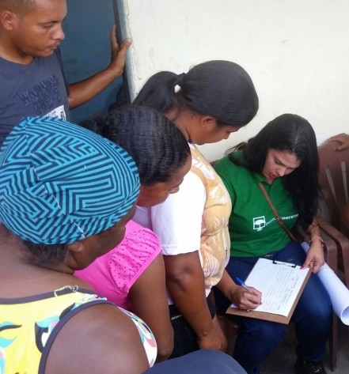 Community Agents take the lead**. The role of Perene´s female team members has always been important in facilitating communication with women. Empowered to be active in this new role, local women become role models of competent, communicative female leadership, inspiring other women to step forward and be vocal and participative as well.
2. **Word of Mouth, Door to Door.** With functional illiteracy near 30% of adults, and no newspaper, postal mail or internet services reaching most of the households, word of mouth has been the most reliable way of reaching people.
3. 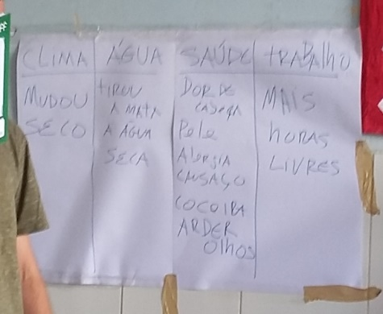**Clear description of the Project.** Traditionally in rural Brazil women are responsible for cooking in the family, more than men, and therefore when it is made clear that the Project centers around Improved Wood-burning Cookstoves, women have shown great interest in participating.
4. **Daytime and Weekend.** In general, women in the region avoid circulating after nightfall because of concerns of personal safety. This was an important factor that led to the stakeholder meeting being held during the day. Sunday was also deemed to be the best day as most people in the region, men and women alike, take a rest from their agricultural and other livelihood activities.
5. **Families Welcome**. All meetings that Perene holds are open to children of all ages, and this is clearly expressed at the time of the invitation. Often women do not have any one with whom to leave their young ones, and so being able to bring them to the meeting enables these mothers to participate.
6. **Group Poster.** Perene tested a new method of recording Sustainable Development feedback, which proved successful. In order to overcome the reluctance people typically show when they are asked to fill out individual written assessments, poster paper was affixed to the wall during the Stakeholder meeting and participants were invited to make their comments orally. This was much easier, with many comments being made by both women and men, and the Perene director writing these comments on the poster.

The Local Stakeholder Consultation Meeting took place on Sunday October 1, 2017. The turn out was very positive, with a total of 77 local participants, from young adults to senior citizens, in addition to several children who accompanied their parents. Of the adults, 47 participants, 60%, were women.

During the meeting, Director Guilherme Valladares explained Perene´s efficient cookstove program and of the two projects underway in neighboring municipalities. It was clarified that beneficiaries are required to use wood as their primary fuel and to give an in-kind contribution of bricks and cement in order to receive the stove. It was explained that each participant signs a Terms of Agreement at the time the household receives the stove. The Natura funding opportunity for a new cookstove project in the region was outlined. Mr. Valladares clarified that funding has not been guaranteed yet and that Perene is in the process of submitting a proposal and hopes to be selected. Deadline of October 13 for submitting proposal was shared, and that we expect to know the results by December 15, 2017. If selected by Natura, the new cookstove project would begin in January or February 2018. The Grievance Mechanisms were presented and discussed, as described in the LSCM Report. The Sustainable Development Assessment exercise was also carried out, in which participants discussed and listed positive impacts, including on health and cleanliness of the home, reduced time spent collecting wood, and improved protection of forests, animals and natural springs. Only one negative point was brought up by a participant of the meeting: that the project may not actually occur. There is, in fact, the possibility that Perene´s project will not be among those selected by Natura, and this was shared with the group. Perene Director explained that as soon as the selection process is complete, feedback will be given to the community.

The principal financing stakeholder is the Brazilian company Natura, which is ultimately the buyer of the carbon credits. Consultation with Natura occurs frequently, as Perene has three carbon-credit contracts underway with the company, and is participating in a Tender, closing October 13, 2017, to fund this new cookstove project. Natura clarified to Perene that to be eligible for funding the project must be Validated or at least under review. Since the Tender deadline is October 13, Perene consulted with Natura to determine if this new PDD will be eligible. Natura responded that, in the case of Perene, since we have been project developers for the Natura Carbon Offset program since 2009, it will be sufficient to obtain a letter from Gold Standard Foundation that the project is currently under Validation review. The Tender can be accessed at:

https://www.ekos.social/pages/natura-itau

No local policy makers or authorities were invited to the informative meetings as this project intends to be independent of government entities, programs or agendas. This precaution prevents any association with a political party and reduces the effects of political changes in the area. In addition, avoiding involvement of the government minimizes the possibility of the project being affected by attempts at corruption. Perene has worked this way for over 10 years, and it has been one of the reasons we have succeeded in building and maintaining a relationship of trust and engagement with our partner communities.

**Feedback Round**

The format chosen for the Feedback Round was twofold: public consultation for NGO supporters and other stakeholders with email/internet access, and Focus Groups with local stakeholders. The project documentation, including Project Design Document and Local Stakeholder Consulation Report, were made available through the following channels: hard copies at Instituto Perene´s headquarters, by link in the Feedback email sent out to Gold Standard NGO supporters, and on the Markit Registry website.

Over the course of two days, January 3- 4, 2018, Instituto Perene held two Focus Groups with local participants in order to give feedback on how the comments and suggestions made during the first round of stakeholder consultation were taken into account.

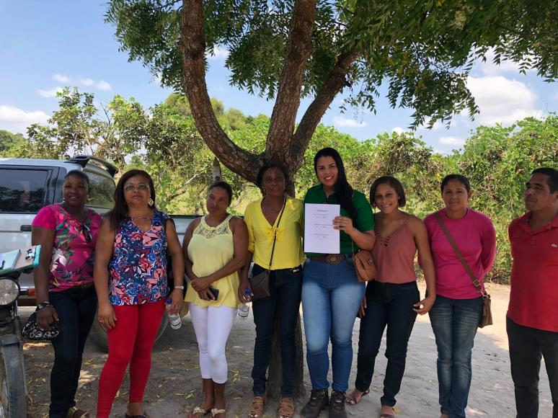On Day 1, the Focus Group was for men, and on Day 2, the Focus Group was led by women, with the exception of one male participant who was interested in becoming a Community Agent. Instituto Perene does not discriminate based on gender, therefore Otavio Silva was accepted into the group and made to feel welcome by all the women.

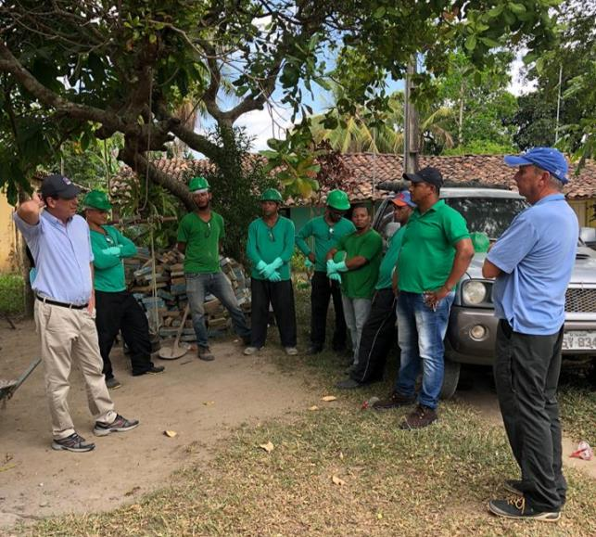

5 Stakeholder Feedback Round Focus Groups

The original participant lists are included in Appendix 1 of the Local Stakeholder Consultation Report.

* + 1. Summary of comments received

>> *(Provide a summary of key comments received during the consultation process.)*

|  |  |  |
| --- | --- | --- |
| **Stakeholder comment** | **Was comment taken into account (Yes/ No)?** | **Explanation (Why? How?)** |
| Is this project part of a political agenda, or will it depend on our support to a particular politician? | Yes | There is great skepticism among poor communities of political initiatives. Often promises are made but do not result in concrete benefits. Perene´s director explained at length that this project has no connection with any candidate or political party, and will not depend on the results of elections. |
| In order to be eligible for funding through the Natura Tender, projects must be Validated or demonstrate to be in process of Validation. | Yes | Perene adjusted the stakeholder meeting to permit all documents necessary for Gold Standard review to be submitted by the Tender deadline of October 13. |
| Smoke from wood-fires causes our eyes to tear and sting | Yes | The efficient stove model Perene constructs is equipped with a durable cermic chimney. |
| Besides eye problems, smoke causes headache, tiredness and allergies | Yes | Comments discusses and included in the Sustainability Assessment. Community Agent explained that the stove reduces the smoke significantly and that proper cleaning of the stove is important to make sure the air flow is not blocked. Details on cleaning griddle, combustion chamber and chimney were NOT shared at this time, as it is premature to talk about the stove operation and maintenance until funding has been secured and there is certainty that the stoves will be built in this region. |
| Most of the participants said they do not find wood near their house and have to walk to collect fuelwood. | Yes | Comment was discussed and potential positive impact of less time spent in fuel collecting was included in Sustainability Assessment. |
| One participant voiced concern that the project may not actually be implemented. | Yes | The director of Perene explained in detail that at this moment Perene is seeking funds for the project but that it is a selection process by the company Natura and we will not know if the stoves can be built until the selection process is over and results are made public. Typically it takes 2-3 months after the Tender closes (October 13) for results to be announced, at which time Perene will communicate the results with the community. |
| Participants asked who could receive the stove. | Yes | It was explained that the stove is for households that use mostly wood for cooking, and that commit to using and maintaining the new cookstove. Further that the project is not for any homes that have only a gas stove or use wood only occasionally and that this would be verified at the time of construction and during monitoring visits. |
| Participants asked if they had to pay anything to receive the new stove. | Yes | Perene explained that an in-kind contribution of bricks and cement for the stove base was required. All other components – griddle, combustion chamber, fuel shelf, chimney, bricks and cement for stove housing, and labor, would be covered by the project. |

Recording comments in Grievance Mechanism Book

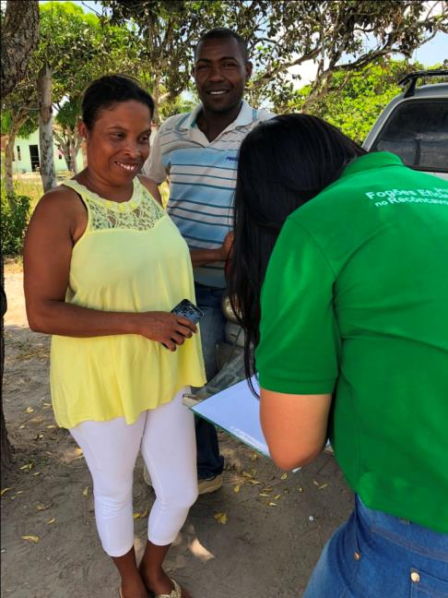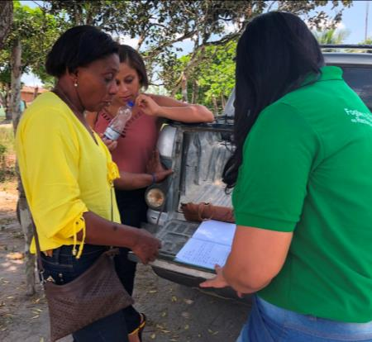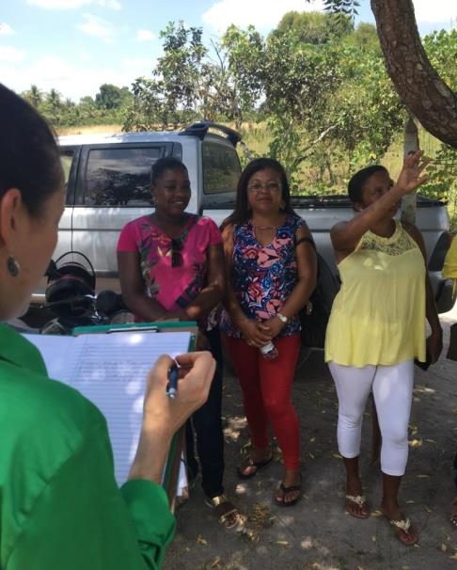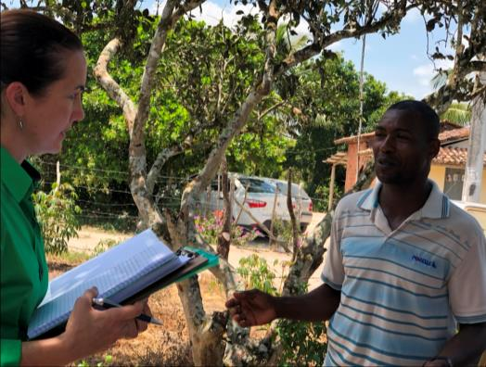

**Social media has become the newest means of stakeholder engagement, reaching over 800 people, most of whom are from Reconcavo region.**

Comments and views of the Instituto Perene Facebook posts can be seen in the screenshots above and by visiting the Facebook page at [www.facebook.com/Instituto-Perene-118949438172366/](http://www.facebook.com/Instituto-Perene-118949438172366/). Over 830 visitors to the page viewed the photos and several comments were made, all positive.

There was no feedback received by email from NGO Supporters, although email confirmation receipt was requested and confirmed for approximately 40 recipients from the Gold Standard International NGO network.

* + 1. Report on consideration of comments received

>> *(Describe how the comments have been addressed by providing a clarification to the stakeholder or by altering the design of the project or by proposing to monitor any anticipated negative impacts etc.)*

Several modifications were made during the design process of the cookstove model due to user comments. Women cooks were very vocal about preferring a built-in stove to a portable model, and having two burners instead of one. Other design changes in the stove resulting from stakeholder comments include the addition of a stove base and the construction technique for laying the bricks. Based on feedback from stakeholders in the Efficient Stoves I project, metal chimneys are no longer used, and instead ceramic chimneys will be used in all Efficient Cookstoves in Bahia III installations.

It is important to note here that the entire design process for the regional stove model was participatory, with the active participation of local community members to design an appropriate stove for their needs. Instituto Perene's specific geographic focus on the Reconcavo Region of Bahia state, with its similar social, economic and environmental characteristics means that the rural communities are quite similar in current practices, making the current stove model readily acceptable in the communities of the Efficient Stoves III project.

The new Meeting Evaluation Report Template will be

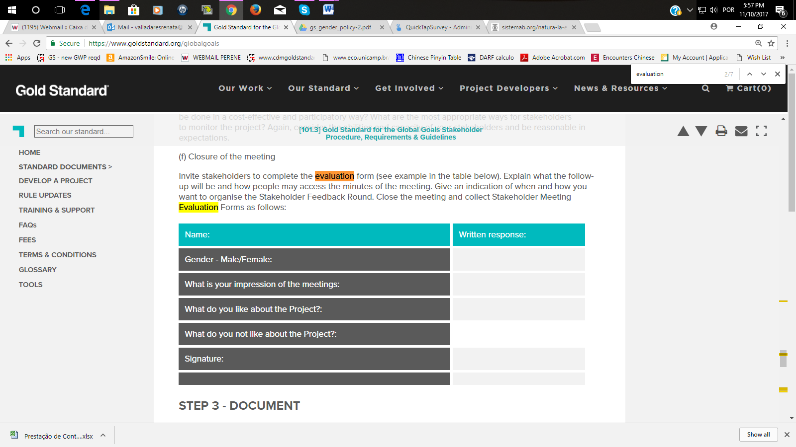

**Feedback Round**

Both Focus Groups were very productive, and were documented through written records, photos and videos. Each participant introduced herself/himself and spoke about her/his experience with the questions. Participants were also invited to record comments in the Grievance Mechanism book, presented after the table. All points brought up in the first Stakeholder Consultation Round were discussed and feedback was given as to how the project incorporated or addressed the issues, as outlined in the table below. Several improvements were made to the project based on the stakeholder comments and the feedback from the Focus Group participants was very positive. Each issue is presented below.

|  |  |  |  |
| --- | --- | --- | --- |
| **Stakeholder comment from Round 1** | **Was comment taken into account (Yes/ No)?** | **Explanation (Why? How?)** | **Response in Feedback Round** |
| Is this project part of a political agenda, or will it depend on our our support to a particular politician? | Yes | There is great skepticism among poor communities of political initiatives. Often promises are made but do not result in concrete benefits. Perene´s director explained at length that this project has no connection with any candidate or political party, and will not depend on the results of elections. | Participants in the Focus Group discussed this question at length and agreed on the importance of clarifying that the project has no political affiliation. Please see video clip of Community Agent Renata Silva Souza speaking on this point.  **Video link:** https://www.dropbox.com/s/a7rurddei9f19on/GS6050\_Focus%20Group%20Feedback%20\_video1.MOV?dl=0 |
| In order to be eligible for funding through the Natura Tender, projects must be Validated or demonstrate to be in process of Validation. | Yes | Perene adjusted the stakeholder meeting to permit all documents necessary for Gold Standard review to be submitted by the Tender deadline of October 13. | This is an on-going negotiation between Natura and Perene. |
| Smoke from wood-fires causes our eyes to tear and sting | Yes | The efficient stove model Perene constructs is equipped with a durable cermic chimney. | All responses from Focus Groups confirmed the harmful effects of smoke on vision and health in general. See comments entered in Grievance Mechanism Book by Otavio Silva, translated from Portuguese: *My mother is 81 years old. We took her to the Health Clinic because she was having difficulty breathing, was very tired and felt ill. The doctor said it was the smoke, years of smoke. My mother had 14 children, and spent the whole day burning wood. That old type of stove smokes too much. My mother is better now, after 2 months of [medical] treatment.* |
| Besides eye problems, smoke causes headache, tiredness and allergies | Yes | Comments discusses and included in the Sustainability Assessment. Community Agent explained that the stove reduces the smoke significantly and that proper cleaning of the stove is important to make sure the air flow is not blocked. Details on cleaning griddle, combustion chamber and chimney were NOT shared at this time, as it is premature to talk about the stove operation and maintenance until funding has been secured and there is certainty that the stoves will be built in this region. | As above, Focus Groups discussed at length the problems associated with smoke in the traditional stoves and the enormous improvement in household air with the new stove. Community Agents shared information about maintaining the stove clean, removing ashes and charcoal from fuel entrance, removing and cleaning the stove top, oiling the stove top to prevent rust, and removing soot from the side access. |
| Most of the participants said they do not find wood near their house and have to walk to collect fuelwood. | Yes | Comment was discussed and potential positive impact of less time spent in fuel collecting was included in Sustainability Assessment. | The Monitoring Survey questions were shared and considered appropriate by the Focus Group participants:  With the new stove (more/less/same) time is spent collecting wood than with the old stove.  The new stove uses (more/less/same) amount of wood than the old stove. |
| One participant voiced concern that the project may not actually be implemented. | Yes | The director of Perene explained in detail that at this moment Perene is seeking funds for the project but that it is a selection process by the company Natura and we will not know if the stoves can be built until the selection process is over and results are made public. Typically it takes 2-3 months after the Tender closes (October 13) for results to be announced, at which time Perene will communicate the results with the community. | The same information was reiterated as this depends on the funder and not on local participants. Participants Djara de Jesus and Sonia dos Santos expressed that there is a high large demand for the stove in their communities. Please see video clip.  **Video Link:**  https://www.dropbox.com/s/ekypip89aq0qv70/GS6050\_Focus%20Group%20Feedback\_video2.MOV?dl=0 |
| Participants asked who could receive the stove. | Yes | It was explained that the stove is for households that use mostly wood for cooking, and that commit to using and maintaining the new cookstove. Further that the project is not for any homes that have only a gas stove or use wood only occasionally and that this would be verified at the time of construction and during monitoring visits. In order to clarify this common doubt, Perene made the following alteration: Three simple questions were included on the reverse side of the Terms of Agreement, as detailed in Section v below. The questions serve as a pre-registration step in order to determine if the person is eligible to sign the agreement and participate in the agreement. | The alteration to the Terms of Agreement was met with widespread approval and enthusiasm by Focus Group participants.  There was extensive discussion in both Focus Groups about the means of verifying that only eligible households receive the stoves. Masons stated that most of the time the new stove is built in the place of the baseline stove and that it is therefore a simple task to confirm baseline stove use. Homes that rely primarily on wood are readily identified by their blackened walls and roof, pots and pans and stacked firewood.  See Community Agent Supervisor Camila dos Anjos explaining the new questions included on the reverse side of the Terms of Agreement.  Video Link:  https://vimeo.com/251951179 |
| Participants asked if they had to pay anything to receive the new stove. | Yes | Perene explained that an in-kind contribution of bricks and cement for the stove base was required. All other components – griddle, combustion chamber, fuel shelf, chimney, bricks and cement for stove housing, and labor, would be covered by the project. | Masons described the importance of all participating households in a community being ready with the materials by the construction date in order to avoid wasting time in returning to the location. |
| Some participants want to include an oven in the stove model. | No | This has been a request from the start of the project, however due to funding and technical constraints, it is not possible at this time to equip the stove model with an oven. | Bajara de Jesus Rocha noted in the Grievance Mechanism book that the stove would be better if it included an oven. The response was given Construction Supervisor Roque de Souza that it was not technically possible. Furthermore, it was discussed in the women´s Focus Group that many cooks have succeeded in baking cakes over the Project stove using a cake pan with a hole in the middle, placed over the larger burner, and covered by a larger pan to trap the heat. |
| HIVOS stated in an email 15Sep2017 that the organization is not in favour of creating carbon credits that can be used for offsetting purposes based on the introduction of LPG stoves which is a fossil fuel. | Yes | Response was given by email 19Sep17, explaining Perene´s position that LPG has important potential in rural Brazil to substitute non-renewable biomass. In any case, the point is moot as the funding identified for project GS6050 targets only efficient wood-burning cookstoves. | The project information in the PDD and LSC was revised to include only efficient wood-burning stoves . |

**Revisions to PDD made in response to Validation Report**

The Table below summarizes the responses from PD to each of the requests made during the Validation review process.

|  |
| --- |
| 1. **Project Information and Project Participants** |
| 1. The number of estimated amount of SDG impact certified shall be consistent throughout all the sections of PDD, 7600tCO2 or 7642tCO2. 2. The PD shall select a certification path way, i.e. project certification or impact statements & products. 3. The PD shall clearly include the exact number of households or stoves that will be involved in the project activity. 4. Evidence of project operational lifetime equal to 10 years shall be submitted for GS validation. |
| **Response from PD (Round I):** |
| 1. OK. Corrected to read 76,425 total and 7,642 throughout the PDD. 2. OK. Impact Statements & Products select. We understand this is the correct choice for the future generation of VERs. 3. OK, it was included in several different section that 3,000 stoves will be installed, benefitting 3,000 families. 4. OK. Explanation and references included. |
| 1. GS Eligibility |
| 1. 1) The PP shall note that all GS4GG projects/activities are required to mandatorily apply the Gold Standard Gender Equality Guidelines & Requirements. The requirements consist of two pathways:    1. Foundation gender-sensitive requirements: These requirements are mandatory for all projects and include compliance with the Gender Safeguarding Principles and Requirements and gender sensitive stakeholder consultations.    2. Pro-active gender-responsive approach: This applies to projects that fulfill the requirements of the gender-sensitive grade and proactively conduct gender analysis and undertake actions to intentionally address gender gaps and contribute to gender equality and women’s empowerment. Such projects are eligible to obtain certified gender impacts under SDG 5 and other relevant SDGs.   There is a total of 3 for Pathway 1 steps to demonstrate compliance which requires all project developers to complete a gender safeguards assessment and gender-sensitive stakeholder consultations as part of initial project design and feasibility. Meeting these requirements enables projects to be ‘Gender-sensitive’. After completing Step 3, project developers should be able to indicate how gender sensitive the project design is. This is a mandatory foundational requirement that applies to all Gold Standard certifications. |
| Response from PD (Round I): |
| 1. OK. Pathway 1 and Steps 1-3 outlined in Section A.2 Eligibility and brief explanation included for each step. |
| 1. Application of the Applied Methodology |
| 1. The PD shall also include justification on applicability condition 2-4 of the applied methodology. 2. The evidence of thermal efficiency of project stove shall be submitted for validation. 3. The reference of historical data for baseline fuel consumption shall be submitted for validation. 4. The PD shall clarify how the historical data is relevant to the target population from characteristics of households, fuel consumption type, survey date valid and etc. |
| Response from PD (Round I): |
| 1. OK. Justifications 2 through 4 completed. 2. OK. WBT report included in Annex 3. 3. OK. References included in Annex 2\_1 through Annex 2\_4. 4. OK. Clarification included in Section B.4 |
|  |
| 1. Sustainable Development Goals outcomes |
| 1. Section B.6.2 on ‘explanation of methodological choices/approaches for estimating the SDG outcome’ and Section B.6.4 ‘Ex ante estimation of outcomes’ linked to each of the three SDGs shall be filled in the PDD. 2. Besides of SDG13 outcome, the PD shall also provide a summary of ex ante estimates of SDG 5 & 7 The PD shall specify the SDG target together with its monitoring indicator/parameter for each of three SDGs address by the project. For details, please refer to http://www.un.org/sustainabledevelopment/sustainable-development-goals/. 3. The PD shall note that to claim a positive contribution to SDG # 5, the project shall apply and demonstrate compliance to the GS Gender Equality Guidelines & Requirements. In case PP does not wish to apply the gender guidelines, information/data on SDG # 5 can be reported in project documentation, but will not be certified as ‘positive’ by GS. Please refer to the guidelines [here](https://www.goldstandard.org/project-developers/standard-documents) for more information. |
| Response from PD (Round I): |
| 1. OK. Explanation of methodological choices and ex-ante outcomes included for each SDG. 2. OK. Ex-ante estimates included for SDG 5& 7. However, for SDG 5, these were not included in section B.6.2 because the Gender parameters are not FIXED, rather they are monitored, and therefore included in B.7. 3. The project aims to apply and comply with the GS Gender Equality Guidelines & Requirements. |
|  |
| 1. Monitoring Plan |
| 1. Measurement method and procedures, Monitoring frequency, QA/QC procedures as well as purpose of data for each of three SDGs monitoring shall be added in the monitoring plan. |
| Response from PD (Round I): |
| 1. OK. All fields included in the Monitoring Plan for each SDG Indicator. |
|  |
| 1. Safeguarding Principles Assessment |
| 1. The PD shall complete the entire safeguarding principles assessment by addressing all the principles listed in the GS Safeguarding Principles and Requirements document. 2. Certain principles have mandatory requirements. The PD shall justify the mandatory requirements have been met by the project activity. |
| Response from PD (Round I): |
| 1. OK. All Principles included in Table. SOCIAL & ECONOMIC SAFEGUARDING PRINCIPLES 1-6 and ENVIRONMENTAL & ECOLOGICAL SAFEGUARDING PRINCIPLES 1-3. Two Principles changed from “No” to “Potential” with mitigation measures included. 2. OK. All Mandatory Requirements included. |
|  |
| 1. Local Stakeholder Consultation |
| 1. 1) The PD shall explain how the stakeholder consultation has been designed considering the various gender elements as required by the GS Gender Guidelines. For e.g., the PD shall discuss what measures and actions were put in place to ensure equal gender participation and how the inputs and insights from both men and women have been sought out, listened to, considered, addressed and documented. The PD shall also clarify if any specific arrangements were made to ensure that all constituencies are engaged in the consultation (speak to women and men separately; have focus groups for women and focus groups for men before gathering them together to ensure their meaningful participation; adapt timing schedule to men’s and women’s working schedules). 2. 2) The PD shall update the templates of the stakeholder evaluation forms as per the GS Stakeholder Procedure, Requirements and Guidelines document. |
| 1. Response from PD (Round 1): |
| 1. 1) OK. Measures listed and described. 2. 2) OK. New template included in PDD and will be used for feedback meeting. |
|  |
| 1. Other |
| 1. The PD shall upload a copy of the updated GS4GG Terms and Conditions and Cover Letter on GS Registry. |
| Response from PD (Round 1): OK uploaded |
|  |
|  |

| Date of GS feedback - I round: 21/02/2018 II round: 19/03/2018 | | | |
| --- | --- | --- | --- |
| **Sections** | **Clarifications and/or corrective action needed** | **Reasons for clarification and/or corrective action**  **Suggestions on how to proceed** | **Response by Project Proponent** |
| VPA Design Document | | | |
| Cover Page | PD shall submit the proof of start date of 01/01/2018. |  | Project did NOT start on Jan 1, 2018. New start date is expected to be April 01, 2018 – the actual start date of construction depends on disbursement of funds by Natura, which is contingent upon Validation and therefore Perene cannot specify the actual date at this time. The event marking project start date will be the date the contract is signed with the local construction company. The event marking crediting period start date will be the start of construction, as evidenced by the Project Database and supporting documents. |
| Cover Page | 1. PD shall clearly mention the version number of the methodology. |  | OK. Version 1.0 included |
| Section A.3 | PD shall upload a sample copy of the signed carbon credits transfer contract to the GS registry. |  | OK, sample from GS1028 uploaded. No contracts for GS6050 have been signed yet as PD cannot guarantee to the local population that stoves will be constructed as funding is contingent on Validation. See FAR #2. |
| Section A.7 | 1. PD shall clarify a bit on the funding status of the project activity. |  | Ok, status updated. |
| Section B.4 | 1. PD is recommended to use other options available in the methodology to determine baseline since a fuel wood consumption value of around 11 kgs/day/HH i.e. 4200/365 seems to be very high. | As per the methodology, for option (a) the project proponents need to make sure that historical data is relevant to the target population and appropriately justified. | Perene requests that this comment be included as a FAR, as it will take considerable time to organize and execute a baseline study based on another option, as recommended by GS. By including this as FAR, Perene will submit new baseline study in time for Verification I. See FAR #3. |
| Section B.5 | 1. The project activity is a Type II project and hence the eligibility for additionality shall be demonstrated in terms of annual energy savings and not as per tCo2 saved. |  | OK, corrected to show annual energy savings. |
| Section B.6.1 | 1. PD shall opt for relevant target for each of the SDGs in line with http://www.un.org/sustainabledevelopment/energy/. |  | Ok, targets copied directly from the UN Global Goals website |
|  | PP shall remove contribution to SDG 5 from the project documentation as Steps 4-6 of the Gender Guidelines are required to be followed in order to claim any positive contribution to this SDG. |  | Ok, SDG 5 removed and replaced by SDG 1. |
| Section B.6.3 | 1. PD shall include relevant information in section B.6.3. |  | Ok, outcomes included. |
| Section B.7.1 | 1. PD shall include value of Up,y,Np,y and DFp,stove,y used for ex-ante estimations of ERs. |  | Ok, included. |
| Section B.7.3 | 1. PD shall include information on monitoring survey carried out annually. |  | Ok, included. |
| Section C.1.1. | 1. PD shall include the event which signifies the start date of 01/01/2018 and submit proof of start date on the GS registry. |  | Revised to 01/04/2018 |
| Section D.1 | 1. Mitigation actions against the potential risk perceived by the project activity shall be included as monitored parameters in the monitoring plan by the PD. |  | Ok, mitigation actions included in the table of section B.7.1 |
| Section E | 1. PD shall include information on the Stakeholder Feedback round. |  | Ok, included. |

**Summary of Forward Action Requests (FARs):**

**Forward Action Request # 1: The PD shall submit results of WBT in time for 1st verification.**

**Forward Action Request # 2: The PD shall submit a signed copy of the carbon credits transfer contract to the GS registry prior to 1st verification.**

**Forward Action Request # 3: PD shall submit the results of baseline survey/baseline KPT in time for verification and prior to request for issuance.**

WORKS CITED

Bryden, M., Still, D., Scott, P., & Hoffa, G. (2002). *Design Principles for Wood Burning Cookstoves.* Eugene, Oregon: Aprovecho Research Center.

Coelho, S. e. (2014). Fuel wood consumption in Brazilian residential sector, energy consumption in households.. *ResearchGate.*

de Castro, J. (2011). Dimensão e Mensuração da Pobreza na Bahia. Salvador. Obtido em September de 2017, de https://pt.slideshare.net/luizdenis/ipea-bahia-010711-dimenso-e-mensurao-da-pobreza-na-bahia1

de Souza, P. a. (2012). *Perfil da Pobreza na Bahia e sua Evolução no Período 2004-2009.* Brasilia: Instituto de Pesquisa Econômica Aplicada.

Falieri, A. (2009). *Multitemporal Land Use and Land Cover Change Analysis and Dynamic Landscape Modeling for the City of Maragogipe - BA.* Salvador.

Falieri, A. (2011). *Análise do desmatamento no Municipio de Maragogipe - BA.* Recife.

FAO. (1987). *Simple Technologies for Charcoal Making.* FAO Forestry Department.

Gabriella Refratarios. (s.d.). *Technical Specifications - Refractory Bricks 229x114x25mm.* Obtido de www.gabrefratarios.com.br

Gioda, A. (2017). *Queima de lenha e carvão - Poluição do ar e riscos para a saúde.* Pontifícia Universidade Católica , Rio de Janeiro.

Global Alliance for Clean Cookstoves. (2011). *Brazil Feasibility Study.*

GlobalGeo. (2012). *Análise Multitemporal dos Remanescentes Florestais no Municipio de São Felipe - BA.* Nova Lima.

IBGE. (2011). *Anuario Estatistico do Brasil.* Instituto Brasileiro de Geografia e Estatistica.

IBGE. (2011). *ANUÁRIO ESTATÍSTICO DO BRASIL* (Vol. 71). Rio de Janeiro: Instituto Brasileiro de Geografia e Estatísticas.

IPEA. (2010). *National Research by Sample Households study.* Obtido de Instituto de Pesquisa Econômica Aplicada: www.ipea.gov.br/portal/images/stories/PDFs/comunicado/100401\_comunicadoipea42.pdf

Metzker, T. (25 de June de 2011). Forest dynamics and carbon stocks inRio Doce State Park – an Atlanticrainforest hotspot. *Current Science, 100*(12).

Ministerio da Justiça e da Cidadania. (2017). *Poder e Participação Política*. Obtido em setembro de 2017, de Secretaria Especial de Politicas para as Mulheres: http://www.spm.gov.br/assuntos/poder-e-participacao-politica

Ministry of Justice and Citizenship. (2017). *Igualdade de Gênero no Campo, na Floresta, nas Águas*. Obtido em Setembro de 2017, de http://www.spm.gov.br/assuntos/mulheres-do-campo-e-da-floresta

Ministry of Mines and Energy. (2016). *Brazilian Energy Balance.*

Ministry of Mines and Energy of Brazil. (2010). *Balanço Energetico Nacional.*

Oliveira, A. (2010). Dînamica Territorial do Recôcavo Baiano: Espacialidade e Temporalidade. *Anais XVI Encontro Nacional dos Geógrafos.* Porto Alegre.

Peter Scott. (s.d.). *Simple Plans to Build the Justa Stove.* Obtido em 31 de August de 2011, de Aprovecho Research Center: www.aprovecho.org/lab/pubs/rl/stove-design/doc/35/raw

Portland Cement Association. (s.d.). *Autoclaved Aerated Concrete*. Obtido em 01 de September de 2011, de Portland Cement Association: http://www.cement.org/homes/ch\_bs\_autoclaved.asp#advantages

SEINFRA BA. (2014). *Balanço Energetico da Bahia.* State Government of Bahia, Secretariat of Infrastructure.

Sindigas. (2013). *Evolução do Preço do GLP.* Obtido em 6 de August de 2014, de National Union of LPG Distributors: http://www.sindigas.org.br/Estatistica/Default.aspx?ano=2013&cat=5

Siqueira, L., & Mesquita, C. (2007). *Meu Pé de Mata Atlantica: Experiencias de recomposição florestal em propriedades particulares no corredor central.* Rio de Janeiro: Instituto BioAtlantico.

Smith, K. R. (2006). Health impacts of household fuelwood in developing countries. *Forests and human health - FAO*.

Winrock International - Shell Foundation. (2007). *Brazil Market Analysis for Improved Stoves.*

1. Contact information of project participants

|  |  |
| --- | --- |
| **Organization name** | Instituto Perene |
| **Registration number with relevant authority** | 08.598.053/0001-68 Cadastro Nacional de Pessoas Jurídicas do Brasil |
| **Street/P.O. Box** | Rua Belo Horizonte 64 Suite 310 |
| **Building** | Edificio Barra Master |
| **City** | Salvador |
| **State/Region** | Bahia |
| **Postcode** | 40140-380 |
| **Country** | Brazil |
| **Telephone** | +55-72-3264-3199 |
| **Fax** | +55-71-3264-3199 |
| **E-mail** | [renata@perene.org.br](mailto:renata@perene.org.br) |
| **Website** | [www.perene.org.br](http://www.perene.org.br) |
| **Contact person** | Guilherme Valladares |
| **Title** | Executive Director |
| **Salutation** | Mr. |
| **Last name** | Valladares |
| **Middle name** |  |
| **First name** | Guilherme |
| **Department** |  |
| **Mobile** | +55-71-99995-2021 |
| **Direct fax** | +55-72-3264-3199 |
| **Direct tel.** | +55-72-3264-3199 |
| **Personal e-mail** | guilherme@perene.org.br |

1. Summary of post registration design changes

Revision History

|  |  |  |
| --- | --- | --- |
| Version | Date | Remarks |
| 1.1 | 24 August 2017 | Updated to include section A.8 on ‘gender sensitive’ requirements |
| 1 | 10 July 2017 | Initial adoption |
|  |  |  |
|  |  |  |
|  |  |  |

1. Conversion rate from Table VIII.8 of BEN (Ministry of Mines and Energy of Brazil, 2010, p. 209) [↑](#footnote-ref-1)
2. Conversion rate from Table VIII.8 of BEN (Ministry of Mines and Energy of Brazil, 2010, p. 209) [↑](#footnote-ref-2)
3. https://pt.climate-data.org/location/854/ [↑](#footnote-ref-3)